|  |  |
| --- | --- |
| a | **MINISTRY OF**  **EDUCATION AND TRAINING** |

**CAPSTONE PROJECT REPORT**

**Report 3 – Software Requirement Specification**

- Hanoi, December 2021 -

Table of Contents

Acronyms and Definitions 1

Record of changes 1

Report III. Software Requirement Specification 2

1. Project Overview 2

2. User Requirement 2

2.1. Actors 2

2.2. Use Cases 3

2.2.1. Overview 3

2.2.2. Feature “Login and Register” 4

2.2.2.1. Login 4

2.2.2.2. Register 5

2.2.2.3. Forgot password 7

2.2.3. Feature “Manage personal profile 9

2.2.3.1. View personal profile 9

2.2.3.2. Edit personal profile 10

2.2.3.3. Change password 11

2.2.3.4. View diet 12

2.2.4. Feature “Manage system accounts” 13

2.2.4.1. View system account list 13

2.2.4.2. View account detail 15

2.2.4.3. Search system account 15

2.2.2.3. Create Nutritional Expert Account 16

2.2.5. Feature “Search Food” 18

2.2.5.1. Search Food 18

2.2.5.2. Search Ingredient 20

UC-13. Search Ingredient by Ingredient Name 20

2.2.6. Feature “Receive diet” 21

2.2.6.1. Receive diet 22

2.2.5.5. Change diet 23

2.2.5.5. View diet 24

2.2.7. Feature “Manage Food” 24

2.2.7.1. Add Food 25

2.2.7.2. Add Ingredient 27

2.2.7.3. Delete Food 28

2.2.7.4. Delete Ingredient 29

2.2.7.5. Update Food Information 30

2.2.7.6. Update Ingredient Information 31

3. Functional Requirement 33

3.1. System Functional Overview 33

3.1.1. Screen Flow 33

3.1.1.1. User 33

3.1.1.2. Admin 34

3.1.1.3. Nutrition Expert 35

3.1.2. Screen Descriptions 36

3.1.2.1. User 36

3.1.2.2. Nutrition Expert 37

3.1.2.3. Admin 37

3.1.3. Screen Authorization 37

3.1.4. Entity Relationship Diagram 39

3.2. Feature “Authenticate user” 41

3.2.1. Login 41

3.2.2. Register 42

3.2.4. Forgot password 43

3.2.5. Email Validation 43

3.3. Feature “Manage personal profile” 44

3.3.1. Personal options 45

3.2.2. Edit personal profile 45

3.2.3. Change password 46

3.2.4. Personal Schedule 47

3.4. Feature “Manage system accounts” 49

3.4.1. System account management 49

3.4.2. Account details 50

3.5. Feature “Search foods” 51

3.5.1. Search Food 51

3.5.2. Search Ingredient 53

3.6. Feature “Manage food” 54

3.6.1. Add and Delete foods 54

3.6.2. Edit Food 56

3.6.3. Add and delete ingredient 57

3.6.2. Edit Ingredient 58

3.7. Feature “Receive diet” 59

3.7.1. View personal diet 59

3.7.2. Input lacked information 60

3.7.3. Summary personal information 62

3.7.4. Diet Detail 63

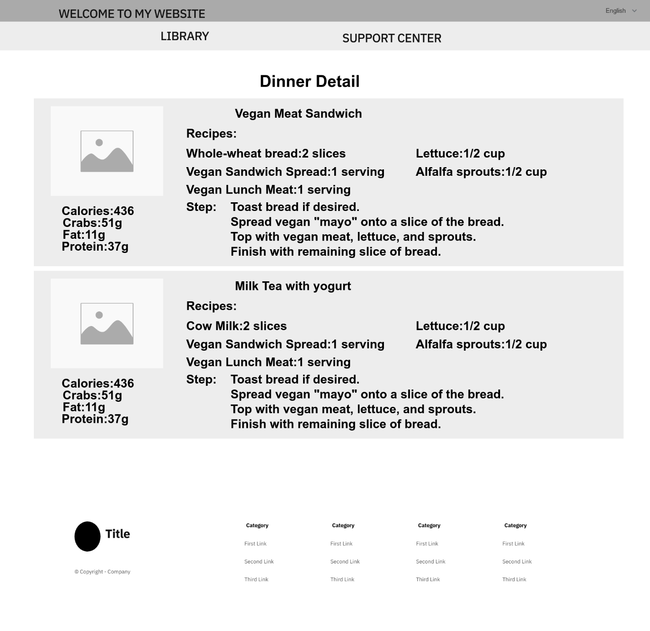 65

4. Non-Functional Requirement 66

4.1. Usability 66

4.2. Security 66

4.3. Performance 66

4.4. Maintaining & Scalability 66

4.5. Compatibility 66

5. Requirement Appendix 66

5.1. Business Rules 66

5.2. Application Message List 68

# Acronyms and Definitions

|  |  |  |
| --- | --- | --- |
| **#** | **Acronym** | **Definition** |
|  |  |  |

Acronyms and Definitions Table

# Record of changes

|  |  |  |  |
| --- | --- | --- | --- |
| **Date** | **Status** | **In charge** | **Change description** |
| 11/20/2022 | A | VietNH | Add all headings for report |
| 11/30/2022 | M | VietNH | Fix some heading titles |
| 12/08/2022 | A | VietNH | Complete Project Overview |
| 12/09/2022 | A | VietNH | Complete User Requirement |
| 12/10/2022 | A | VietNH | Complete Functional Requirement, Non-Functional Requirement |
| 12/11/2021 | A | VietNH | Complete Requirement Appendix |

A – Added, M – Modified, D – deleted

# Report III. Software Requirement Specification

## 1. Project Overview

The 4HeathyNutrium aims to provide suggestions and advice on reasonable nutrition and exercise for users. The system packs feature up into a website, where the users can easily access to. The diagram below illustrates the external entities and system interfaces for first-time release.

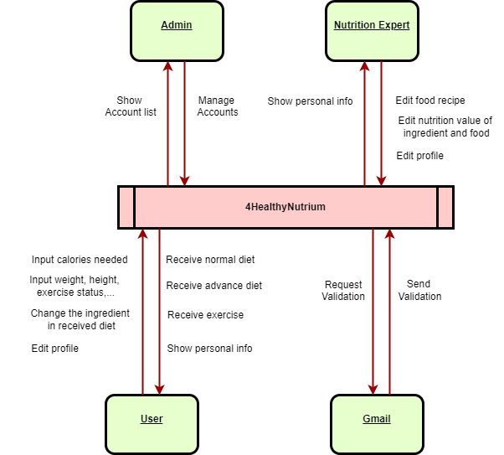

Figure 1. Context Diagram

## 2. User Requirement

### 2.1. Actors

|  |  |  |
| --- | --- | --- |
| **#** | **Actor** | **Description** |
| 1 | User | An user is the person who can receice and change personal diets, and search for foods and ingredients. |
| 2 | Nutrition Expert | An nutrition expert is the person who can edit foods, recipes and ingredients. |
| 3 | Administrator | An admin is the person who has the permission to administer user accounts in the system |

Table 2.1. Actors

### 2.2. Use Cases

#### 2.2.1. Overview

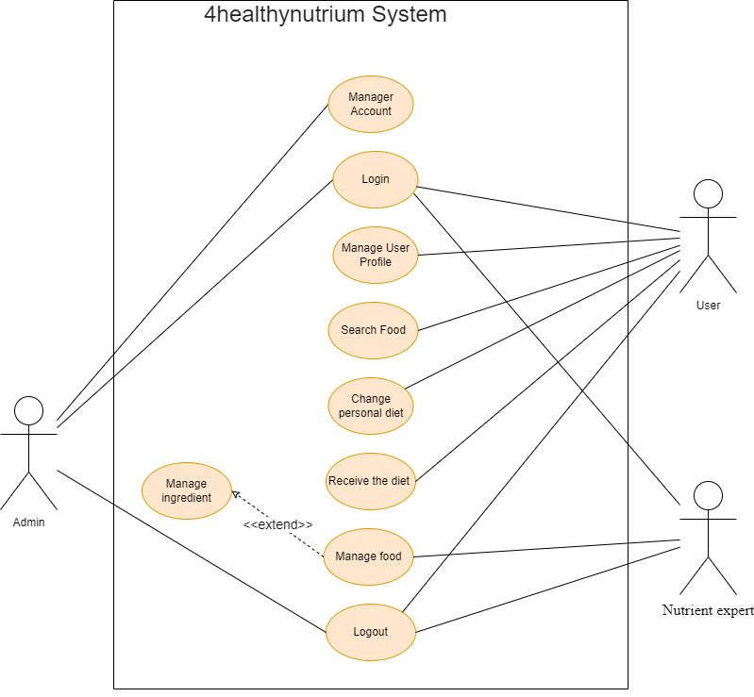

Figure 2.2.1. Overall use case diagram

#### 2.2.2. Feature “Login and Register”

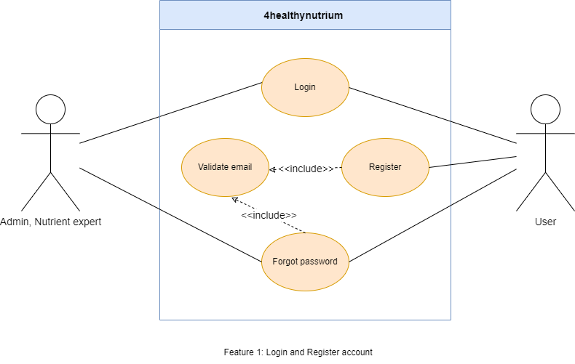

Figure 2.2.2. “Login and Register” use cases

##### 2.2.2.1. Login

|  |  |  |  |
| --- | --- | --- | --- |
| **UC ID and Name:** | **UC-01. Login** | | |
| **Created By:** | VietNH | **Date Created:** | 10/02/2022 |
| **Primary Actor:** | User, Nutrition Expert, Admin | **Secondary Actors:** | N/A |
| **Trigger:** | N/A | | |
| **Description:** | This use case allows the user to login into the system. | | |
| **Preconditions:** | **PRE-01.** The user has registered an account in the system.  **PRE-02.** The user’s phone number has not been banned in the system. | | |
| **Post-conditions:** | **POST-01.** The system saves the user’s login session token. | | |
| **Normal Flow:** | **1.0. Login to the system**   1. The user access to the system. 2. The system displays the Login screen.    1. A required text field to input the username.    2. A required text field to input the user’s password. 3. The user inputs his/her username and password, then presses on the “Login” button to login. 4. The system validates and the user logged in successfully. | | |
| **Alternative Flows:** | N/A | | |
| **Exceptions:** | **1.0.E1. Wrong username or password**  1. In step 3, if the user inputs the wrong username or password.  2. The system rejects the user’s login attempt and displays an error message (MSG01).  **1.0.E2. Leave required fields blank**  1. In step 3, if the user logs in without providing a username or password.  2. The system rejects the user’s login attempt and displays error messages (MSG02).  **1.0.E3.** **The user inputs the wrong password format**  1. The user inputs a password less than 8 characters.  2. The system rejects the user’s attempt and displays an error message (MSG03). | | |
| **Priority:** | High | | |
| **Frequency of Use:** | High | | |
| **Business Rules:** | BR-01, BR-02 | | |
| **Other Information:** | 1. If the user logs out from the system, the system returns to the Login Screen as default. | | |
| **Assumptions:** | N/A | | |

Table 2.2.2.1. Login

##### 2.2.2.2. Register

|  |  |  |  |
| --- | --- | --- | --- |
| **UC ID and Name:** | **UC-02. Register** | | |
| **Created By:** | VietNH | **Date Created:** | 10/02/2022 |
| **Primary Actor:** | User | **Secondary Actors:** | N/A |
| **Trigger:** | **TRIG-01.** The user presses on the “Register” underlining text in the Login Screen. | | |
| **Description:** | This use case allows the user to register a new account to login to the system. | | |
| **Preconditions:** | **PRE-01.** The user must have a username.  **PRE-01.** The user is in the Login Screen. | | |
| **Post-conditions:** | **POST-01.** The system creates an account for the user in the database. | | |
| **Normal Flow:** | **2.0. Register a new account**   1. The user presses on the “Register” underlining text in the Login Screen. 2. The system redirects to the Register Screen and displays the following:    1. A required number field to input the username.    2. Two required text fields to input password and password confirmation.    3. A required combo box field to input gender.    4. A required text field to input the email.    5. A text field to input the address. 3. The user inputs required fields; presses “Next” to continue the process. 4. The system sends the validation code to the user’s email and redirects the user to the Email Validation Screen, displays the following (See other information 1):    1. 6 number cells to input validation code.    2. A countdown timer indicates the next email validation code send request availability.    3. The “Next” button. 5. The user inputs the email validation code and presses the “Next” button to continue the process. 6. The user inputs required fields, any non-required fields and presses the “Register” button. 7. The system registers the user, displays a message (MSG06) and redirects the user back to the Login Screen. | | |
| **Alternative Flows:** | N/A | | |
| **Exceptions:** | **2.0.E1. Leave required fields blank**  1. In step 3, the user registers without filling in the required fields  2. The system rejects the user’s register attempt and displays error messages (MSG02).  **2.0.E2. The user inputs an invalid username**  1. The user inputs an invalid username.  2. The system rejects the user’s register attempt and displays an error message (MSG04).  **2.0.E3. The user inputs wrong password format**  1. The user inputs a password less than 8 characters.  2. The system displays an error message (MSG10).  **2.0.E4. The user inputs unmatched password re-confirmation**  1. In step 3, the user inputs unmatched password re-confirmation, the system displays an error message (MSG06).  **2.0.E5. Use existing username or banned username to register**  1. In step 3, the user inputs existed username or banned username.  2. The system rejects the user’s register attempt and displays an error message (MSG05).  **2.0.E6. The user inputs invalid validation code.**  1. In step 3, the user inputs the invalid validation code.  2. The system rejects the user’s attempt and displays an error message (MSG03). | | |
| **Priority:** | High | | |
| **Frequency of Use:** | High | | |
| **Business Rules:** | BR-03, BR-06, BR-07 | | |
| **Other Information:** | 1. When a validation session is over, the system asks if the user wants to re-send a validation code. The system repeats steps 4 and 5 if the user chooses to resend. | | |
| **Assumptions:** | N/A | | |

Table 2.2.2.2. Register

##### 2.2.2.3. Forgot password

|  |  |  |  |
| --- | --- | --- | --- |
| **UC ID and Name:** | **UC-03. Forgot password** | | |
| **Created By:** | VietNH | **Date Created:** | 10/02/2022 |
| **Primary Actor:** | User, Nutrition Expert | **Secondary Actors:** | N/A |
| **Trigger:** | **TRIG-01.** The user presses on the “Forgot Password?” underline text in the Login Screen. | | |
| **Description:** | The function allows the user to reset the password. | | |
| **Preconditions:** | **PRE-01.** The user is in the Login Screen. | | |
| **Post-conditions:** | **POST-01**. The new password is updated in the system. | | |
| **Normal Flow:** | **3.0. Reset the password in the Forgot Password Screen**   1. The user presses on the “Forgot Password?” underline text in the Login Screen. 2. The system redirects the user to the Forgot Password Screen, displays a required number field for phone number. 3. The user inputs his/her email and presses the “Next” button to continue the process. (See 3.0.E1, 3.0.E2) 4. The system sends the validation code to the user’s email and redirects the user the Validation Email Screen, displays the following field (See other information 1):    1. 6 number cells to input validation code.    2. A countdown timer indicates the next validation send request availability.    3. The “Next” button. 5. The user inputs the validation code and presses on the “validation” button to continue the process (see 3.0.E4). 6. The system validates the validation code and successfully redirects the user to the Change Password Screen, displays two required password and password confirmation fields. 7. The user inputs required fields and press the “Next” button (see 3.0.E1, 3.0.E3, 3.0.E4, 3.0.E5). 8. The system updates a new password, displays a message and navigates the user backs to the Login Screen. | | |
| **Alternative Flows:** | **3.0.E1. Leave required fields blank**  1. The user not filling required fields and press the “Next” button.  2. The system rejects the user’s attempt and displays error messages (MSG01).  **3.0.E2. The user input invalid email**  1. In step 3, The user inputs invalid email.  2. The system rejects the user’s attempt and displays an error message (MSG04).  **3.0.E3. The user inputs wrong password format**  1. In step 7, the user inputs a password less than 8 characters.  2. The system rejects the user’s attempt and displays an error message (MSG01).  **3.0.E4. The user inputs incorrect email validation code**  1. In step 7, the user inputs incorrect email validation code.  2. The system rejects the user’s attempt and displays an error message (MSG03).  **3.0.E5. Password confirmation does not match**  1. In step 7, the user inputs a different password confirmation.  2. The system rejects the user’s attempt, display an error message (MSG06). | | |
| **Exceptions:** | N/A | | |
| **Priority:** | High | | |
| **Frequency of Use:** | Low | | |
| **Business Rules:** | BR-06 | | |
| **Other Information:** | 1. When an Email Validation session is over, the system asks if the user wants to re-send an email validation code. The system repeats steps 4, 5 if the user chooses to resend. | | |
| **Assumptions:** | N/A | | |

Table 2.2.2.3. Forgot password

#### 2.2.3. Feature “Manage personal profile

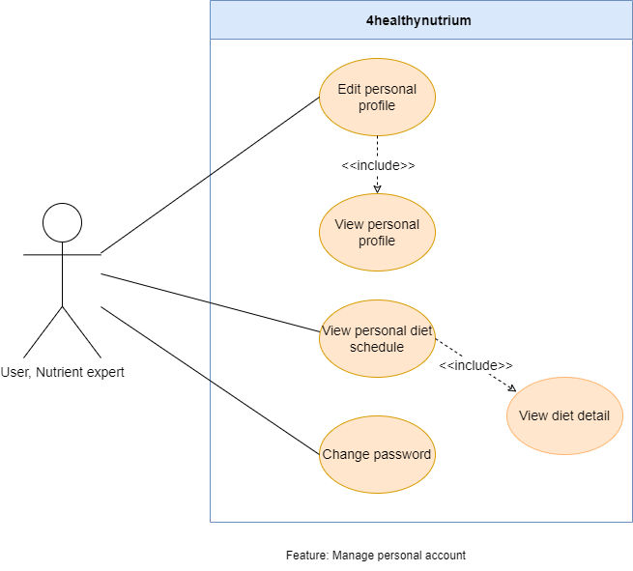

Figure 2.2.3. “Manage personal profile” use cases

##### 2.2.3.1. View personal profile

|  |  |  |  |
| --- | --- | --- | --- |
| **UC ID and Name:** | **UC-04. View personal profile** | | |
| **Created By:** | VietNH | **Date Created:** | 10/02/2022 |
| **Primary Actor:** | Users | **Secondary Actors:** | N/A |
| **Trigger:** | **TRIG-01.** The user presses on the “Edit Personal Information” option in the Personal Setting Screen. | | |
| **Description:** | This use case allows the user to view his/her profile information. | | |
| **Preconditions:** | **PRE-01.** The user has logged in.  **PRE-02.** The user is in the Personal Profile Setting Screen. | | |
| **Post-conditions:** | N/A | | |
| **Normal Flow:** | **4.0. View the user profile**   1. After PRE-01, PRE-02 are confirmed, the user presses on the “Edit Personal Information” option. 2. The system redirects to the Edit Personal Profile Screen, displays fields containing information of the user:    1. Required text field for name    2. Required date selector for birthdate   Non-required fields are: Gender, Address, Province, District, Ward. | | |
| **Alternative Flows:** | N/A | | |
| **Exceptions:** | N/A | | |
| **Priority:** | High | | |
| **Frequency of Use:** | High | | |
| **Business Rules:** | N/A | | |
| **Other Information:** | 1. If the user has not input any non-required field (Gender, Address, Age, Height, Weight) when registering in the Register Information Screen, fields will display as empty. | | |
| **Assumptions:** | N/A | | |

Table 2.2.3.1. View personal profile

##### 2.2.3.2. Edit personal profile

|  |  |  |  |
| --- | --- | --- | --- |
| **UC ID and Name:** | **UC-05. Edit personal profile** | | |
| **Created By:** | VietNH | **Date Created:** | 10/02/2022 |
| **Primary Actor:** | Users | **Secondary Actors:** | N/A |
| **Trigger:** | **TRIG-01.** The user presses on the “Save changes” button. | | |
| **Description:** | The function allows the user to edit his/her profile information | | |
| **Preconditions:** | **PRE-01.** The user has logged in.  **PRE-02.** The user is in the Edit Personal Profile Screen. | | |
| **Post-conditions:** | **POST-01**. The system updates the user’s profile changes. | | |
| **Normal Flow:** | **5.0. The user edits personal profile**   1. The user makes any changes to any field in the Edit Personal Profile Screen and presses the “Save changes” button to save new changes (see 6.0.E1).   The system updates new changes. | | |
| **Alternative Flows:** | N/A | | |
| **Exceptions:** | **5.0.E1. The user leaves the required fields empty**  1. The user deletes data in required fields and presses the “Save changes” button.  2. The system rejects the user’s attempt, and displays error messages (MSG02). | | |
| **Priority:** | High | | |
| **Frequency of Use:** | Low | | |
| **Business Rules:** | BR-03 | | |
| **Other Information:** | N/A | | |
| **Assumptions:** | N/A | | |

Table 2.2.3.2. Edit personal profile

##### 2.2.3.3. Change password

|  |  |  |  |
| --- | --- | --- | --- |
| **UC ID and Name:** | **UC-06. Change password** | | |
| **Created By:** | VietNH | **Date Created:** | 10/02/2022 |
| **Primary Actor:** | User, Nutrition Expert | **Secondary Actors:** | N/A |
| **Trigger:** | **TRIG-01.** The user presses on the “Change Password” option in the Personal Setting Screen. | | |
| **Description:** | This use case allows the user to change his/her password. | | |
| **Preconditions:** | **PRE-01.** The user has logged in.  **PRE-02.** The user is in the Personal Setting Screen. | | |
| **Post-conditions:** | **POST-01.** The system updates the user’s new password. | | |
| **Normal Flow:** | **6.0 The user changes the password**   1. The system redirects the user to the Change Password Screen, display the following fields:    1. Required text field to input old password.    2. Required text field to input new password.    3. Required text field to input new password confirmation. 2. The user inputs required fields and presses the “Save change” button (see 6.0.E1, 6.0.E2, 6.0.E3, 6.0.E4).   The system updates the new password, displays a message (MSG12) and logs out the user. | | |
| **Alternative Flows:** | N/A | | |
| **Exceptions:** | **6.0.E1. Leave required fields blank.**  1. In step 2, the user does not input the required fields before saving.  2. The system rejects the user’s attempt, display error messages (MSG02).  **6.0.E2 The user inputs wrong password format**  1. The user inputs password less than 8 characters and presses the “Change Password” button.  2. The system rejects the user’s attempt, and displays an error message (MSG01).  **6.0.E3 The user inputs the new password matched with the old password**  1. In step 2, the user inputs the new password matched with the old password and presses the “Change Password” button.  2. The system rejects the user’s attempt, displays an error message (MSG07).  **6.0.E4** **Password confirmation does not match**  1. The user inputs a different password confirmation and the “Change Password” button.  2. The system rejects the user’s attempt, displays an error message (MSG06). | | |
| **Priority:** | High | | |
| **Frequency of Use:** | Low | | |
| **Business Rules:** | BR-07 | | |
| **Other Information:** | N/A | | |
| **Assumptions:** | N/A | | |

Table 2.2.3.3. Change password

##### 2.2.3.4. View diet

|  |  |  |  |
| --- | --- | --- | --- |
| **UC ID and Name:** | **UC-07. View fishing location overview** | | |
| **Created By:** | VietNH | **Date Created:** | 10/02/2022 |
| **Primary Actor:** | User | **Secondary Actors:** | N/A |
| **Trigger:** | **TRIG-01.** The user presses on the “My diet” button in the navigation bar. | | |
| **Description:** | This use case allows the user to view the fishing location overview. | | |
| **Preconditions:** | **PRE-01.** The user has logged in.  **PRE-02.** The user is in the “My diet” Screen. | | |
| **Post-conditions:** | N/A | | |
| **Normal Flow:** | **15.0. Go to “My Profile” screen.**  1. After PRE-01 is confirmed, the user presses on “My Profile” screen.  2. The system will send user to “Personal Schedule Screen”, which display diet information in current day. | | |
| **Alternative Flows:** | **15.1. Go to “My diet” screen.**   1. After PRE-01, PRE-02 is confirmed, the system display the Detail Diet.    1. If the user have their diet in database, the system will display user’s diet information in current day.    2. If the user don’t have their diet in database, the system will display nothing. 2. If the user clicks onto the button “I want eat this”, then back to screen “My diet”. | | |
| **Exceptions:** | N/A | | |
| **Priority:** | High | | |
| **Frequency of Use:** | High | | |
| **Business Rules:** | N/A | | |
| **Other Information:** |  | | |
| **Assumptions:** | N/A | | |

#### 2.2.4. Feature “Manage system accounts”

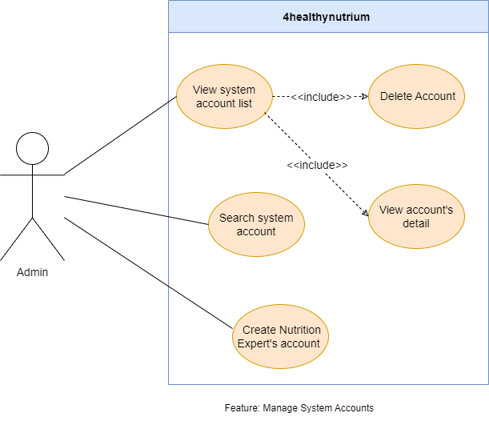

Figure 2.2.4. “Manage system accounts” use cases

##### 2.2.4.1. View system account list

|  |  |  |  |
| --- | --- | --- | --- |
| **UC ID and Name:** | **UC-08. View system account list** | | |
| **Created By:** | VietNH | **Date Created:** | 10/02/2022 |
| **Primary Actor:** | Admin | **Secondary Actors:** | N/A |
| **Trigger:** | **TRIG-01.** The admin presses on “Accounts Management” option in the Admin Setting Screen. | | |
| **Description:** | The function allows the admin to view all user’s accounts registered in the system. | | |
| **Preconditions:** | **PRE-01.** The user must login with an admin account.  **PRE-02.** The admin is in the Admin Setting Screen. | | |
| **Post-conditions:** | N/A | | |
| **Normal Flow:** | **8.0. View list of accounts in the system**   1. The admin presses on the “Accounts Management” option in the Admin Setting Screen. 2. The system redirects the admin to the System Account Management Screen, display the following:    1. A search bar to search by email.    2. A combo box includes 2 role Users and Nutrition Expert.   List of all accounts in the system, each item in the list displays the summary of the account, includes avatar, name, email and account status. | | |
| **Alternative Flows:** | N/A | | |
| **Exceptions:** | N/A | | |
| **Priority:** | High | | |
| **Frequency of Use:** | High | | |
| **Business Rules:** | N/A | | |
| **Other Information:** | N/A | | |
| **Assumptions:** | N/A | | |

Table 2.2.4.1. View system account list

##### 2.2.4.2. View account detail

|  |  |  |  |
| --- | --- | --- | --- |
| **UC ID and Name:** | **UC-09. View account detail** | | |
| **Created By:** | VietNH | **Date Created:** | 02/10/22 |
| **Primary Actor:** | Admin | **Secondary Actors:** | N/A |
| **Trigger:** | **TRIG-01:** The admin presses on a list item in the System Account List Screen. | | |
| **Description:** | The function allows the admin to view all user’s account details. | | |
| **Preconditions:** | **PRE-01.** The user must login with an admin account.  **PRE-02.** The admin is in the System Account Management Screen. | | |
| **Post-conditions:** | N/A | | |
| **Normal Flow:** | **9.0 View details of the account**   1. The admin presses on a specific list item in the System Account List Screen. 2. The system redirects the admin to the Account Detail Screen, displays the following:    1. Account detail section, displays all information of the account includes: avatar, name, age, email, gender, address and status to describe the locked or unlocked state of the account.    2. A button with label: “Delete Account” to delete account. | | |
| **Alternative Flows:** | N/A | | |
| **Exceptions:** | N/A | | |
| **Priority:** | High | | |
| **Frequency of Use:** | High | | |
| **Business Rules:** | N/A | | |
| **Other Information:** | N/A | | |
| **Assumptions:** | N/A | | |

Table 2.2.4.2. View account detail

##### 2.2.4.3. Search system account

|  |  |  |  |
| --- | --- | --- | --- |
| **UC ID and Name:** | **UC-10. Search system account** | | |
| **Created By:** | VietNH | **Date Created:** | 02/10/22 |
| **Primary Actor:** | Admin | **Secondary Actors:** | N/A |
| **Trigger:** | **TRIG-01.** The admin presses enter on the keyboard after filling in the search bar in the System Account List Screen. | | |
| **Description:** | The function allows the admin to search the system account by phone number or by username. | | |
| **Preconditions:** | **PRE-01.** The user must login with an admin account.  **PRE-02.** The admin is in the System Account List Screen. | | |
| **Post-conditions:** | N/A | | |
| **Normal Flow:** | **10.0.1 Search an account by username in the system**   1. The admin presses to focus on the search bar. 2. The system pops up a keyboard allowing the admin to type in. 3. The user inputs the account's username and presses enter on the keyboard. 4. The system finds matched accounts and displays them in the list of results (See other information 1).   **10.0.2 Search an account by email in the system**   1. The admin presses to focus on the search bar. 2. The system pops up a keyboard allowing the admin to type in. 3. The user inputs the account's email and presses search icon on the screen.   The system finds matched accounts and displays them in the list of results.  **10.0.2 Sort an account by role in the system**   1. The admin presses to focus on the combo box and change between 2 role Users and Nutrition Experts.   The system finds matched accounts and displays them in the list of results. | | |
| **Alternative Flows:** | N/A | | |
| **Exceptions:** | N/A | | |
| **Priority:** | Medium | | |
| **Frequency of Use:** | High | | |
| **Business Rules:** | N/A | | |
| **Other Information:** | 1. The account list returns empty if no records match the username or email. | | |
| **Assumptions:** | N/A | | |

Table 2.2.4.3. Search system account

##### 2.2.2.3. Create Nutritional Expert Account

|  |  |  |  |
| --- | --- | --- | --- |
| **UC ID and Name:** | **UC-11. Create Nutritional Expert Account** | | |
| **Created By:** | VietNH | **Date Created:** | 10/02/2022 |
| **Primary Actor:** | Admin | **Secondary Actors:** | N/A |
| **Trigger:** | **TRIG-01.** The user presses on the “Adding” icon with label “Add new nutrition expert”. | | |
| **Description:** | This use case allows the admin to create a new account for nutritional expert to login to the system. | | |
| **Preconditions:** | **PRE-01.** The admin is in System Account List Screen. | | |
| **Post-conditions:** | **POST-01.** The system creates an account for the nutrition expert in the database. | | |
| **Normal Flow:** | **11.0. Create a new account for nutrition expert**  The admin presses on the “Adding” icon with label “Add new nutrition expert” in the System Account List Screen.   1. The system redirects to the “Nutrition Expert Adding” Screen and displays the following:    1. A required number field to input the username.    2. Two required text fields to input password and password confirmation.    3. A required combo box field to input gender.    4. A required text field to input the email.    5. A text field to input the address.    6. A "Choose Image" button to upload a certification. 2. The user inputs required fields; presses “Next” to continue the process. 3. The system registers the nutrition expert’s account, displays a message (MSG06) and redirects the admin back to the System Account List Screen. | | |
| **Alternative Flows:** | N/A | | |
| **Exceptions:** | **11.0.E1. Leave required fields blank**  1. In step 3, the admin’s creating without filling in the required fields  2. The system rejects the admin’s creating attempt and displays error messages (MSG02).  **11.0.E2. The user inputs an invalid username**  1. The admin inputs an invalid username.  2. The system rejects the admin’s creating attempt and displays an error message (MSG04).  **11.0.E3. The user inputs wrong password format**  1. The user inputs a password less than 8 characters.  2. The system displays an error message (MSG10).  **11.0.E4. The user inputs unmatched password re-confirmation**  1. In step 3, the admin inputs unmatched password re-confirmation, the system displays an error message (MSG06).  **11.0.E5. Use existing username or banned username to register**  1. In step 3, the admin inputs existed username or banned username.  2. The system rejects the admin’s creating attempt and displays an error message (MSG05). | | |
| **Priority:** | High | | |
| **Frequency of Use:** | High | | |
| **Business Rules:** | BR-03, BR-06, BR-07 | | |
| **Other Information:** |  | | |
| **Assumptions:** | N/A | | |

Table 2.2.4.4. Register

#### 2.2.5. Feature “Search Food”

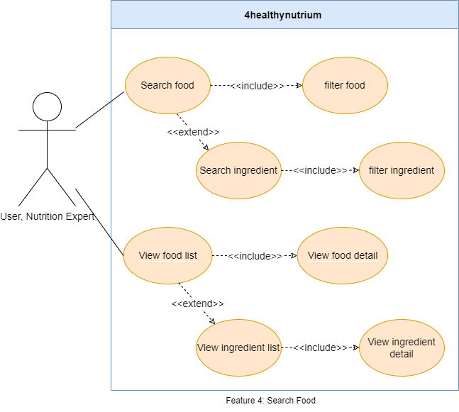

Figure 2.2.5. “Search Food” use cases

##### 2.2.5.1. Search Food

|  |  |  |  |
| --- | --- | --- | --- |
| **UC ID and Name:** | **UC-12. Search Food by Food Name** | | |
| **Created By:** | VietNH | **Date Created:** | 10/02/2022 |
| **Primary Actor:** | Nutrition Expert, Users | **Secondary Actors:** | N/A |
| **Trigger:** | **TRIG-01:** The user or nutrition expert presses on the “Library” icon in the navigation bar.  **TRIG-02:** The user nutrition expert presses on the “Recipe” in the Search Recipe and Ingredient Screen. | | |
| **Description:** | This use case allows the user to search food information which they want to know.  This use case allows the nutrition expert for easier searching food to edit. | | |
| **Preconditions:** | **PRE-01.** The user or the nutrition expert has logged in.  **PRE-02.** The user or the nutrition expert is in the Search Recipe and Ingredient Screen. | | |
| **Post-conditions:** | N/A | | |
| **Normal Flow:** | **12.0 Go to Recipe and Ingredient List Screen**   1. After PRE-01, PRE-02 is confirmed, the user presses on the “Recipe” button in the double button. 2. The system redirects the user to the Recipe List Screen. (See other information 1, 2, 3). 3. The system displays list of food in the database.   **12.0.1 Search a food by its name**   1. The user or nutrition expert presses to focus on the search bar. 2. The system pops up a keyboard allowing the user or nutrition expert to type in. 3. The user and the nutrition expert input the food name and presses search icon on the screen. 4. The system finds matched accounts and displays them in the list of results.   **12.0.2 Filter a food by category in the system**   1. The user or nutrition expert presses to focus on the combo box and choose which category they want to filter.   The system finds matched category and displays them in the list of results.  **12.0.3 Filter a food by season in the system**   1. The user or nutrition expert presses to focus on the combo box and choose which season they want to filter.   The system finds matched season and displays them in the list of results. | | |
| **Alternative Flows:** | N/A | | |
| **Exceptions:** | N/A | | |
| **Priority:** | High | | |
| **Frequency of Use:** | High | | |
| **Business Rules:** | N/A | | |
| **Other Information:** | 1. The food list returns empty if no records match the food name. | | |
| **Assumptions:** | N/A | | |

Table 2.5.5.1. Search Food

##### 2.2.5.2. Search Ingredient

|  |  |  |  |
| --- | --- | --- | --- |
| **UC ID and Name:** | UC-13. Search Ingredient by Ingredient Name | | |
| **Created By:** | VietNH | **Date Created:** | 10/02/2022 |
| **Primary Actor:** | Nutrition Expert, Users | **Secondary Actors:** | N/A |
| **Trigger:** | **TRIG-01:** The user or the nutrition expert presses on the “Library” in the navigation bar.  **TRIG-02:** The user or the nutrition expert presses on the “Ingredient” in the Search Recipe and Ingredient Screen. | | |
| **Description:** | This use case allows the user to search ingredient information which they want to know.  This use case allows the nutrition expert for easier searching ingredient to edit. | | |
| **Preconditions:** | **PRE-01.** The user has logged in.  **PRE-02.** The user is in the Search Result Screen. | | |
| **Post-conditions:** | N/A | | |
| **Normal Flow:** | **13.0 Go to Recipe and Ingredient List Screen**   1. After PRE-01, PRE-02 is confirmed, the user presses on the “Recipe” button in the double button. 2. The system redirects the user to the Recipe List Screen. 3. The system displays list of food in the database.   **12.0.1 Search an ingredient by its name**   1. The user or nutrition expert presses to focus on the search bar. 2. The system pops up a keyboard allowing the user or nutrition expert to type in. 3. The user and the nutrition expert input the ingredient name and presses search icon on the screen. 4. The system finds matched ingredient name and displays them in the list of results.   **13.0.2 Filter a food by category in the system**   1. The user or nutrition expert presses to focus on the combo box and choose which category they want to filter.   The system finds matched category and displays them in the list of results.  **13.0.3 Filter a food by season in the system**   1. The user or nutrition expert presses to focus on the combo box and choose which season they want to filter.   The system finds matched season and displays them in the list of results. | | |
| **Alternative Flows:** | N/A | | |
| **Exceptions:** | N/A | | |
| **Priority:** | High | | |
| **Frequency of Use:** | High | | |
| **Business Rules:** | N/A | | |
| **Other Information:** | 1. The ingredient list returns empty if no records match the ingredient name. | | |
| **Assumptions:** | N/A | | |

Table 2.2.5.2. Search ingredient

##### 

#### 2.2.6. Feature “Receive diet”

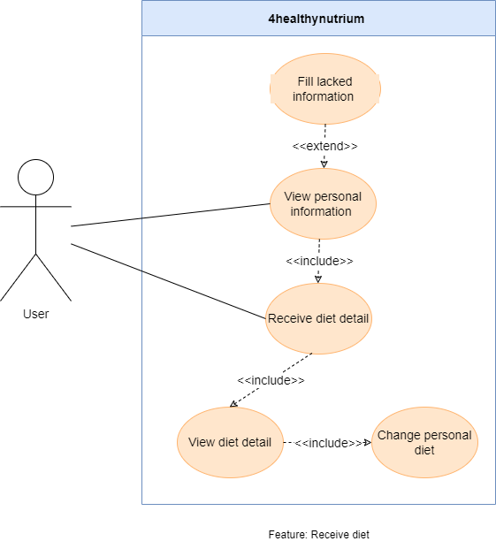

Figure 2.2.6. “Receive diet” use cases

##### 2.2.6.1. Receive diet

|  |  |  |  |
| --- | --- | --- | --- |
| **UC ID and Name:** | **UC-14. View fishing location overview** | | |
| **Created By:** | VietNH | **Date Created:** | 10/02/2022 |
| **Primary Actor:** | User | **Secondary Actors:** | N/A |
| **Trigger:** | **TRIG-01.** The user presses on the “My diet” button in the navigation bar.  **TRIG-02.1.** If user’s data about weight, height, job, frequency exercise haven’t existed in database. User have to fill this information in “Input height and weight” screen, “Input frequency exercise” screen, “Input job” screen.  **TRIG-02.2** If user’s data about weight, height, job, frequency exercise haven’t existed in database, redirect to “Diet Detail Screen”. | | |
| **Description:** | This use case allows the user to view the fishing location overview. | | |
| **Preconditions:** | **PRE-01.** The user has logged in.  **PRE-02.** The user is in the My Diet Screen.  **PRE-03.** If user’s data about weight, height, job, frequency exercise haven’t existed in database, they have to fill it in required screens. | | |
| **Post-conditions:** | N/A | | |
| **Normal Flow:** | **14.0.1 Go to My diet screen (have already had necessary information)**   1. After PRE-01 is confirmed, the user presses on the “My diet” button in the navigation bar. 2. The system redirects the user to the My diet Screen. 3. The system displays user’s information in “Summary Profile Screen”. 4. If user press “Receive my diet” button, display an alert message (MSG15). If user choose “Yes”, they will go to screen “Diet Detail” which show their diet for a day.   **14.0.2 Go to My diet screen (haven’t had necessary information)**   1. After PRE-01 is confirmed, the user presses on the “My diet” button in the navigation bar. 2. The system redirects the user to the My diet Screen. 3. The system will display “Input height and weight” screen, “Input frequency exercise” screen, “Input job” screen. User have to fill all of these screens to receive their diet. 4. The system displays user’s information in “Summary Profile Screen”. 5. If user press “Receive my diet” button, display an alert message (MSG15). If user choose “Yes”, they will go to screen “Diet Detail” which show their diet for a day. | | |
| **Alternative Flows:** |  | | |
| **Exceptions:** | N/A | | |
| **Priority:** | High | | |
| **Frequency of Use:** | High | | |
| **Business Rules:** | N/A | | |
| **Other Information:** | 1. By pressing “Yes” button when alert message (MSG15) exists, the current information of the user is in will be saved and can be later viewed in the My Profile Screen. | | |
| **Assumptions:** | N/A | | |

Table 2.2.5.4. Receive diet

##### 2.2.5.5. Change diet

|  |  |  |  |
| --- | --- | --- | --- |
| **UC ID and Name:** | **UC-15. View fishing location overview** | | |
| **Created By:** | VietNH | **Date Created:** | 10/02/2022 |
| **Primary Actor:** | User | **Secondary Actors:** | N/A |
| **Trigger:** | **TRIG-01.** The user presses on the “My diet” button in the navigation bar.  **TRIG-02:** The user nutrition expert presses on the “Recipe” in the Search Recipe and Ingredient Screen. | | |
| **Description:** | This use case allows the user to view the fishing location overview. | | |
| **Preconditions:** | **PRE-01.** The user has logged in.  **PRE-02.** The user is in the “Receive diet detail” Screen. | | |
| **Post-conditions:** | N/A | | |
| **Normal Flow:** | **15.0. When user have already received their daily personal diet.**   1. After PRE-01, PRE-02 is confirmed, the system display the Detail Diet. 2. If the user wants to change foods in their diet, click onto “Swap” icon in the right of food displayed. 3. The system displays another food which still meet the requirements. 4. If the user clicks onto the button “I want eat this”, then back to screen “My diet”. | | |
| **Alternative Flows:** |  | | |
| **Exceptions:** | N/A | | |
| **Priority:** | High | | |
| **Frequency of Use:** | High | | |
| **Business Rules:** | N/A | | |
| **Other Information:** | 1. By pressing “I want eat this” button, the current information of the user’s diet is in will be saved and can be later viewed in the My Diet. | | |
| **Assumptions:** | N/A | | |

Table 2.2.5.4. Receive diet

##### 2.2.5.5. View diet

|  |  |  |  |
| --- | --- | --- | --- |
| **UC ID and Name:** | **UC-16. View fishing location overview** | | |
| **Created By:** | VietNH | **Date Created:** | 10/02/2022 |
| **Primary Actor:** | User | **Secondary Actors:** | N/A |
| **Trigger:** | **TRIG-01.** The user presses on the “My diet” button in the navigation bar. | | |
| **Description:** | This use case allows the user to view the fishing location overview. | | |
| **Preconditions:** | **PRE-01.** The user has logged in.  **PRE-02.** The user is in the “My diet” Screen. | | |
| **Post-conditions:** | N/A | | |
| **Normal Flow:** | **16.0. Go to “My diet” screen.**   1. After PRE-01, PRE-02 is confirmed, the system display the Detail Diet.    1. If the user has their diet in database, the system will display user’s diet information in current day.    2. If the user doesn’t have their diet in database, the system will display nothing. 2. If the user clicks onto the button “I want eat this”, then back to screen “My diet”. | | |
| **Alternative Flows:** | **16.1. Go to “My Profile” screen.**  1. After PRE-01 is confirmed, the user presses on “My Profile” screen.  2. The system will send user to “Personal Schedule Screen”, which display diet information in current day. | | |
| **Exceptions:** | N/A | | |
| **Priority:** | High | | |
| **Frequency of Use:** | High | | |
| **Business Rules:** | N/A | | |
| **Other Information:** |  | | |
| **Assumptions:** | N/A | | |

Table 2.2.5.4. View diet

#### 2.2.7. Feature “Manage Food”

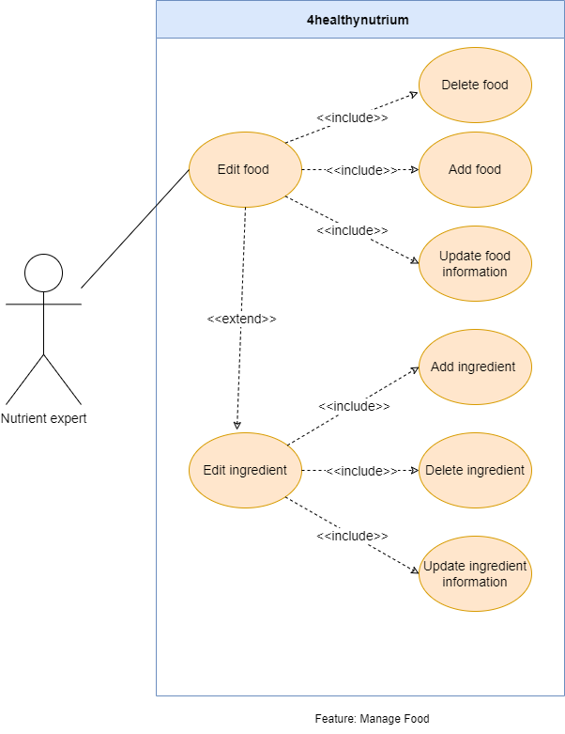

Figure 2.2.7. “Receive diet” use cases

##### 2.2.7.1. Add Food

|  |  |  |  |
| --- | --- | --- | --- |
| **UC ID and Name:** | **UC-17. Add Food** | | |
| **Created By:** | VietNH | **Date Created:** | 10/13/2021 |
| **Primary Actor:** | Nutritional Expert | **Secondary Actors:** | N/A |
| **Description:** | This allows the nutrition expert to add a new food to the system. | | |
| **Trigger:** | **TRIG-01.** The user presses on the “Add Food” button in the Food List Screen. | | |
| **Preconditions:** | **PRE-01.** The nutrition is logged in.  **PRE-02.** The user is in the Food List Screen. | | |
| **Post-conditions:** | **POST-01**. The Food’s information is created in a database.  **POST**-**02.** The Food’s information created will be displayed as a product card in the Food List Screen. | | |
| **Normal Flow:** | **17.0.1. Add new food**   1. After PRE-01, PRE-02 are confirmed, the user presses on the “Add food” button on the screen. 2. The system redirects the user to the Adding Food Screen, displays the following:    1. A required section to upload images of the food.    2. A required text field to input the food name.    3. A required combo box to input meal type.    4. A required combo box to input seasonal type.    5. A required text area labelled “Recipe” to input how to cook this food.    6. A required “adding” icon with list box to add the ingredients.    7. A required text area to input food description.    8. A required text field to input food’s calories value.    9. A required text field to input food’s fat value.    10. A required text field to input food’s carb value.    11. A required text field to input food’s protein value. 3. The user fills in required fields and presses the “Save” button to save the information. 4. The system redirects the nutrition expert back to the Food List Screen, accepts new information in the form, creates a new food, and displays pop-up message (MSG16).   The user presses on the “Confirm” button in the pop-up message to be redirected back to the Food List Screen. | | |
| **Alternative Flows:** | N/A | | |
| **Exceptions:** | **17.0.E1. Leaving the required field blank**  1. In step 4, the nutrition expert leaves required fields blank.  2. The system rejects the nutrition expert’s attempt, displays error messages (MSG02).  **17.0.E2. The nutrition expert does not select the value in combo box**  1. The nutrition expert does not select the meal type and season before pressing the “Save” button.  2. The system rejects the nutrition expert’s attempt, displays an error pop-up message (MSG17).  **17.0.E3. The system failed to create new food information**  1. The system displays an error pop-up message. (MSG17) | | |
| **Priority:** | High | | |
| **Frequency of Use:** | Low | | |
| **Business Rules:** | N/A | | |
| **Other Information:** | 1. If the Food List Screen does not have any food values, the system shows the “Add Food” button in the middle of the screen.  2. The maximum number of images the user can upload within the food profile is 1 image. | | |
| **Assumptions:** | N/A | | |

Table 2.2.9.1. Add Food

##### 2.2.7.2. Add Ingredient

|  |  |  |  |
| --- | --- | --- | --- |
| **UC ID and Name:** | **UC-18. Add Ingredient** | | |
| **Created By:** | VietNH | **Date Created:** | 10/13/2021 |
| **Primary Actor:** | Nutritional Expert | **Secondary Actors:** | N/A |
| **Description:** | This allows the nutrition expert to add a new ingredient to the system. | | |
| **Trigger:** | **TRIG-01.** The user presses on the “Add Ingredient” button in the Ingredient List Screen. | | |
| **Preconditions:** | **PRE-01.** The nutrition is logged in.  **PRE-02.** The user is in the Ingredient List Screen. | | |
| **Post-conditions:** | **POST-01**. The ingredient’s information is created in a database.  **POST**-**02.** The ingredient’s information created will be displayed as a product card in the ingredient List Screen. | | |
| **Normal Flow:** | **18.0.1. Add new food**   1. After PRE-01, PRE-02 are confirmed, the user presses on the “Add ingredient” button on the screen. 2. The system redirects the user to the Adding Ingredient Screen, displays the following:    1. A required section to upload images of the ingredient.    2. A required text field to input the ingredient name.    3. A required text area to input ingredient description.    4. A required text field to input ingredient’s calories value.    5. A required text field to input ingredient’s fat value.    6. A required text field to input ingredient’s carb value.    7. A required text field to input ingredient’s protein value.    8. Required text fields to input ingredient’s vitamin values.    9. Required text fields to input ingredient’s mineral values. 3. The user fills in required fields and presses the “Save” button to save the information. 4. The system redirects the nutrition expert back to the Ingredient List Screen, accepts new information in the form, creates a new food, and displays pop-up message (MSG18).   The user presses on the “Confirm” button in the pop-up message to be redirected back to the Ingredient List Screen. | | |
| **Alternative Flows:** | N/A | | |
| **Exceptions:** | **18.0.E1. Leaving the required field blank**  1. In step 4, the nutrition expert leaves required fields blank.  2. The system rejects the nutrition expert’s attempt, displays error messages (MSG02).  **18.0.E2. The system failed to create new food information**  1. The system displays an error pop-up message. (MSG19) | | |
| **Priority:** | High | | |
| **Frequency of Use:** | Low | | |
| **Business Rules:** | N/A | | |
| **Other Information:** | 1. If the Ingredient List Screen does not have any food values, the system shows the “Add Ingredient” button in the middle of the screen.  2. The maximum number of images the user can upload within the ingredient profile is 1 image. | | |
| **Assumptions:** | N/A | | |

Table 2.2.9.1. Add Ingredient

##### 2.2.7.3. Delete Food

|  |  |  |  |
| --- | --- | --- | --- |
| **UC ID and Name:** | **UC-19. Delete Food** | | |
| **Created By:** | VietNH | **Date Created:** | 10/16/2022 |
| **Primary Actor:** | Nutrition Expert | **Secondary Actors:** | N/A |
| **Trigger:** | **TRIG-01.** The nutrition expert selects the “Delete Food” optionfrom Food List Screen. | | |
| **Description:** | This use case allows the nutrition expert to delete the food in database. | | |
| **Preconditions:** | **PRE-01.** The user has logged in.  **PRE-02.** The user is in the Food List Screen.  **PRE-03.** The data of food in database is not empty. | | |
| **Post-conditions:** | **POST-01.** The system removes the food exists in database. | | |
| **Normal Flow:** | **19.0 Delete Food**   1. After PRE-01, PRE-02, PRE-03 are confirmed, the system displays a pop-up message (MSG09) to ask the user for confirmation. 2. The user presses the “Confirm” button in the pop-up to confirm the process.   The system deletes the selected food and reset Food List Screen. | | |
| **Alternative Flows:** | N/A | | |
| **Exceptions:** | N/A | | |
| **Priority:** | High | | |
| **Frequency of Use:** | Low | | |
| **Business Rules:** | N/A | | |
| **Other Information:** |  | | |
| **Assumptions:** | N/A | | |

Table 2.2.6.4. Delete Food

##### 2.2.7.4. Delete Ingredient

|  |  |  |  |
| --- | --- | --- | --- |
| **UC ID and Name:** | **UC-20. Delete ingredient** | | |
| **Created By:** | VietNH | **Date Created:** | 10/16/2022 |
| **Primary Actor:** | Nutrition Expert | **Secondary Actors:** | N/A |
| **Trigger:** | **TRIG-01.** The nutrition expert selects the “Delete Ingredient” optionfrom Ingredient List Screen. | | |
| **Description:** | This use case allows the nutrition expert to delete the ingredient in database. | | |
| **Preconditions:** | **PRE-01.** The user has logged in.  **PRE-02.** The user is in the Ingredient List Screen.  **PRE-03.** The data of ingredient in database is not empty. | | |
| **Post-conditions:** | **POST-01.** The system removes the ingredient exists in database. | | |
| **Normal Flow:** | **20.0 Delete Ingredient**   1. After PRE-01, PRE-02, PRE-03 are confirmed, the system displays a pop-up message (MSG09) to ask the user for confirmation. 2. The user presses the “Confirm” button in the pop-up to confirm the process.   The system deletes the selected food and reset Ingredient List Screen. | | |
| **Alternative Flows:** | N/A | | |
| **Exceptions:** | N/A | | |
| **Priority:** | High | | |
| **Frequency of Use:** | Low | | |
| **Business Rules:** | N/A | | |
| **Other Information:** |  | | |
| **Assumptions:** | N/A | | |

Table 2.2.6.4. Delete Ingredient

##### 2.2.7.5. Update Food Information

|  |  |  |  |
| --- | --- | --- | --- |
| **UC ID and Name:** | **UC-21 Update Food Information** | | |
| **Created By:** | VietNH | **Date Created:** | 10/20/2022 |
| **Primary Actor:** | Nutrition Expert | **Secondary Actors:** | N/A |
| **Description:** | This allows the Nutrition Expert to edit an existing food profile in the database. | | |
| **Trigger:** | **TRIG-01.** The Nutrition Expert pressed on the "Edit” icon in the Food List Screen. | | |
| **Preconditions:** | **PRE-01.** The nutrition expert is logged in.  **PRE-03.** The nutrition expert is in the Food List Screen. | | |
| **Post-conditions:** | **POST-01.** The food’s profile is updated in the database. | | |
| **Normal Flow:** | **21.0. Edit food’s profile**   1. After PRE-01, PRE-02 are confirmed, the user presses on the “Edit” icon in the right of food card. 2. The system redirects the owner to the Food Screen to edit the current food’s information, displays the following:    1. A required image section to upload an image of Food.    2. A required text field to input the food name.    3. A required combo box to input meal type.    4. A required combo box to input seasonal type.    5. A required text area labelled “Recipe” to input how to cook this food.    6. A required “adding” icon with list box to add the ingredients.    7. A required text area to input food description.    8. A required text field to input food’s calories value.    9. A required text field to input food’s fat value.    10. A required text field to input food’s carb value.    11. A required text field to input food’s protein value. 3. The user fills in required fields and presses the “Save” button to save the information. 4. The system redirects the nutrition expert back to the Food List Screen, accepts new information in the form, creates a new food, and displays pop-up message (MSG16).   The user presses on the “Confirm” button in the pop-up message to be redirected back to the Food List Screen. | | |
| **Alternative Flows:** | N/A | | |
| **Exceptions:** | **21.0.E1. Leaving the required field blank**  1. In step 4, the nutrition expert leaves required fields blank.  2. The system rejects the nutrition expert’s attempt, displays error messages (MSG02).  **21.0.E2. The nutrition expert does not select the value in combo box**  1. The nutrition expert does not select the meal type and season before pressing the “Save” button.  2. The system rejects the nutrition expert’s attempt, displays an error pop-up message (MSG17).  **21.0.E3. The system failed to create new food information**  1. The system displays an error pop-up message. (MSG17) | | |
| **Priority:** | High | | |
| **Frequency of Use:** | High | | |
| **Business Rules:** | BR-11 | | |
| **Other Information:** |  | | |
| **Assumptions:** | N/A | | |

Table 2.2.9.6. Edit Food

##### 2.2.7.6. Update Ingredient Information

|  |  |  |  |
| --- | --- | --- | --- |
| **UC ID and Name:** | **UC-22 Update Food Information** | | |
| **Created By:** | VietNH | **Date Created:** | 10/20/2022 |
| **Primary Actor:** | Nutrition Expert | **Secondary Actors:** | N/A |
| **Description:** | This allows the Nutrition Expert to edit an existing food profile in the database. | | |
| **Trigger:** | **TRIG-01.** The Nutrition Expert pressed on the "Edit” icon in the Ingredient List Screen. | | |
| **Preconditions:** | **PRE-01.** The nutrition expert is logged in.  **PRE-03.** The nutrition expert is in the Ingredient List Screen. | | |
| **Post-conditions:** | **POST-01.** The food’s profile is updated in the database. | | |
| **Normal Flow:** | **22.0. Edit food’s profile**   1. After PRE-01, PRE-02 are confirmed, the user presses on the “Edit” icon in the right of food card. 2. The system redirects the owner to the Ingredient Screen to edit the current food’s information, displays the following:    1. A required image section to upload an image of ingredient.    2. A required text field to input the ingredient name.    3. A required text area to input ingredient description.    4. A required text field to input ingredient’s calories value.    5. A required text field to input ingredient’s fat value.    6. A required text field to input ingredient’s carb value.    7. A required text field to input ingredient’s protein value.    8. Required text fields to input ingredient’s vitamin values.    9. Required text fields to input ingredient’s mineral values. 3. The user fills in required fields and presses the “Save” button to save the information. 4. The system redirects the nutrition expert back to the Ingredient List Screen, accepts new information in the form, creates a new food, and displays pop-up message (MSG18). | | |
| **Alternative Flows:** | N/A | | |
| **Exceptions:** | **22.0.E1. Leaving the required field blank**  1. In step 4, the nutrition expert leaves required fields blank.  2. The system rejects the nutrition expert’s attempt, displays error messages (MSG02).  **22.0.E2. The system failed to update new food information**  1. The system displays an error pop-up message. (MSG17) | | |
| **Priority:** | High | | |
| **Frequency of Use:** | High | | |
| **Business Rules:** | BR-11 | | |
| **Other Information:** |  | | |
| **Assumptions:** | N/A | | |

Table 2.2.9.6. Edit Ingredient

## 3. Functional Requirement

### 3.1. System Functional Overview

#### 3.1.1. Screen Flow

##### 3.1.1.1. User

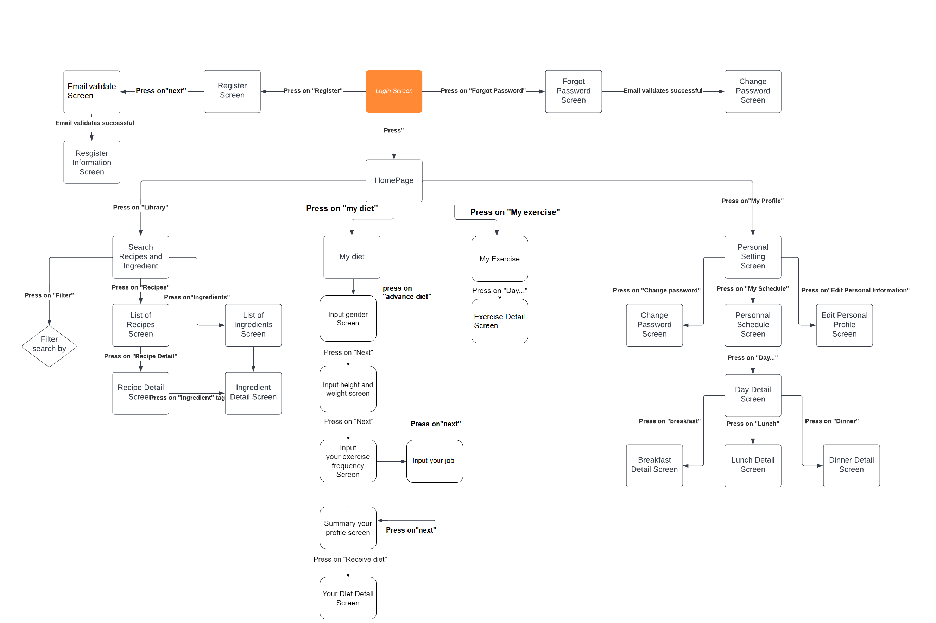

Figure 3.1.1.1. User Screen Flow

##### 3.1.1.2. Admin

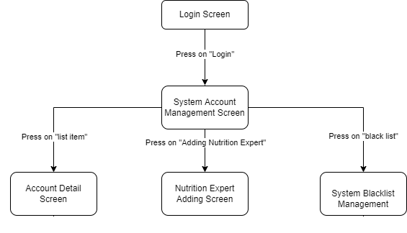

Figure 3.1.1.2. Admin Screen Flow

##### 3.1.1.3. Nutrition Expert

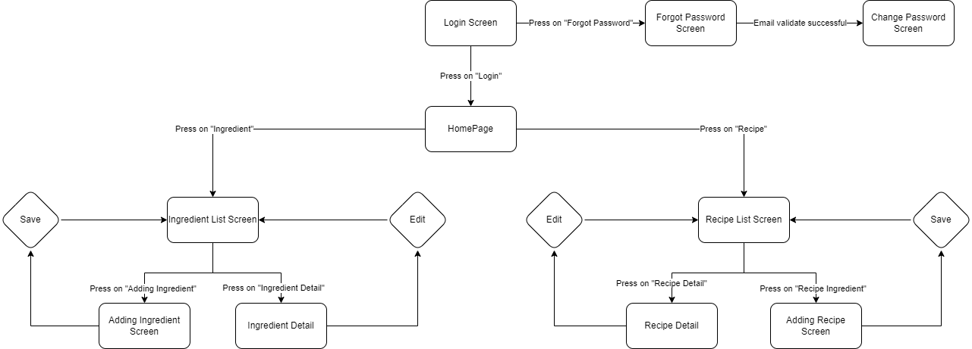

Figure 3.1.1.3. Nutrition Expert Screen Flow

#### 3.1.2. Screen Descriptions

##### 3.1.2.1. User

|  |  |  |  |
| --- | --- | --- | --- |
| **#** | **Feature** | **Screen** | **Description** |
|  | Login and Register | Login | Log in to the system. |
|  | Forgot password | Request change password. |
|  | Register | Register a new account. |
|  | Email Validation | Request email validation. |
|  | Register information | Register personal information for a new account. |
|  | Manage personal profile | Personal setting | View profile management menu. |
|  | Edit personal profile | View and edit personal profile. |
|  | Personal schedule | View personal schedule diets. |
|  | Day Detail | View diet in a day. |
|  | Breakfast Detail | View breakfast diet. |
|  | Lunch Detail | View lunch diet. |
|  | Dinner Detail | View dinner diet. |
|  | Change password | Change old password to new password. |
|  | Search food | Search Food | Searches for all foods information in 4HealthyNutrium library. |
|  | Search Ingredient | Searches for all ingredients information in 4HealthyNutrium library. |
|  | Receive diet | My diet | Show user’s personal diet in a day. |
|  | Input gender | Require the user to enter information. |
|  | Input weight and height | Require the user to enter information. |
|  | Input job | Require the user to enter information |
|  | Input exercise frequency | Require the user to enter information |
|  | Summary profile | View personal recently input information (gender, weight, height, job, exercise frequency, etc.) |
|  | Diet Detail | Show detail diet for user. |
|  | Search food | Search Foods and Ingredients | Show food or ingredient list. |
|  | List of Foods | Show food list. |
|  | List of Ingredient | Show ingredient list. |
|  | Food Detail | Show selected food detail. |
|  | Ingredient Detail | Show selected ingredient detail. |

Table 3.1.2.1. User’s screen descriptions

##### 3.1.2.2. Nutrition Expert

|  |  |  |  |
| --- | --- | --- | --- |
| **#** | **Feature** | **Screen** | **Description** |
|  | Manage food | Add food | Add foods to library. |
|  | Add ingredient | Add ingredients to library. |
|  | Update food | Update food to library. |
|  | Update ingredient | Update ingredient to library. |
|  | Login | Login | Log in to the system. |
|  | Forgot password | Request change password. |
|  | Email Validation | Request email validation. |

Table 3.1.2.2. Nutrition Expert’s screen descriptions

##### 3.1.2.3. Admin

|  |  |  |  |
| --- | --- | --- | --- |
| **#** | **Feature** | **Screen** | **Description** |
|  | Manage system accounts | System account management | Show list of user account in the system, comes with management functions. |
|  | Account detail screen | Show detail of user account. |
|  | Add Nutrition Expert | Add nutrition expert. |

Table 3.1.2.3. Admin’s screen descriptions

#### 3.1.3. Screen Authorization

|  |  |  |  |
| --- | --- | --- | --- |
| **Screen** | **User** | **Nutrition Expert** | **Admin** |
| Login | X | X | X |
| Forgot password | X | X | X |
| Register | X |  |  |
| Register information | X |  |  |
| Personal setting | X |  |  |
| Edit personal profile | X |  |  |
| Change password | X | X | X |
| List of Foods | X | X |  |
| Filter search | X | X |  |
| List of Ingredients | X | X |  |
| Food Detail | X | X |  |
| Ingredient Detail | X | X |  |
| Input gender | X |  |  |
| Input height and weight | X |  |  |
| Input exercise frequency | X |  |  |
| Input job | X |  |  |
| Summary profile | X |  |  |
| My diet | X |  |  |
| My exercise | X |  |  |
| Personal Schedule | X |  |  |
| Day Detail | X |  |  |
| Breakfast Detail | X |  |  |
| Lunch Detail | X |  |  |
| Dinner Detail | X |  |  |
| System Account |  |  | X |
| Account Detail |  |  | X |
| Add Nutrition Expert |  |  | X |
| Add Ingredients |  | X |  |
| Edit Ingredients |  | X |  |
| Email verification | X | X |  |

Table 3.1.3. Screen authorization

#### 3.1.4. Entity Relationship Diagram

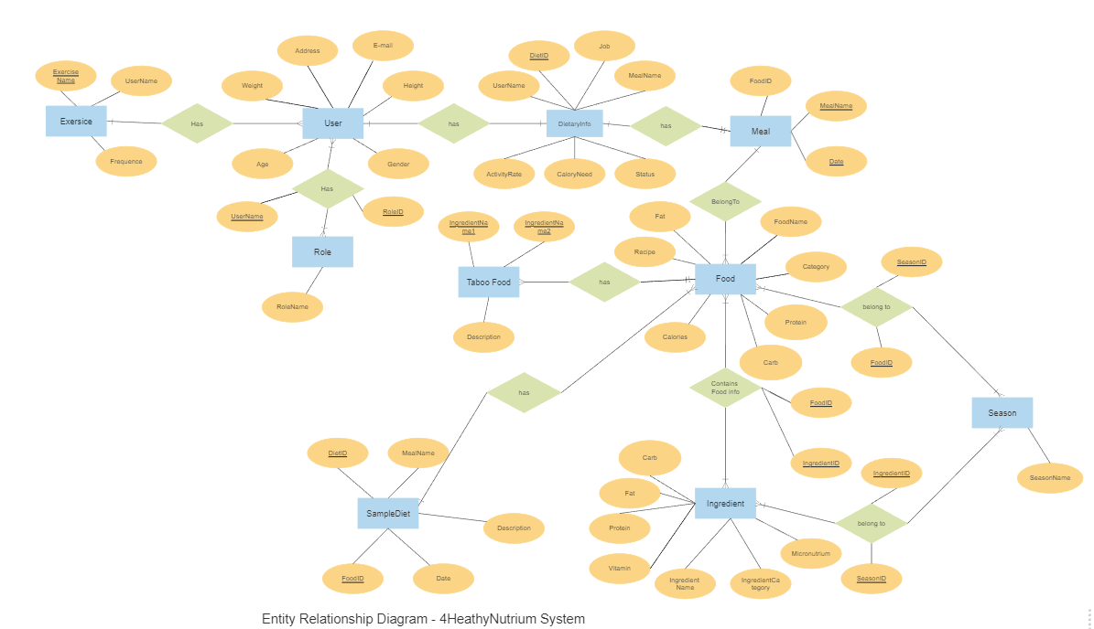

Figure 3.1.4. 4HealthyNutrium Entity Relationship Diagram

|  |  |  |
| --- | --- | --- |
| **ID** | **Entity** | **Description** |
| 1 | User | An actor who uses the system. |
| 2 | Role | A user can have one role only, either normal user or admin. |
| 3 | Dietary Info | User’s diet information. |
| 4 | Meal | Include suggested foods which divided by meal. |
| 5 | Food | Editable by nutrition expert only. |
| 6 | Ingredient | Editable by nutrition expert only. |
| 7 | Taboo Food | Includes ingredients that should not be eaten together. |
| 8 | Season | Include foods and ingredient which divided by season. |
| 9 | Exercise | Contain information about personal exercise. |

Table 3.1.4. Entities Description

### 3.2. Feature “Authenticate user”

#### 3.2.1. Login

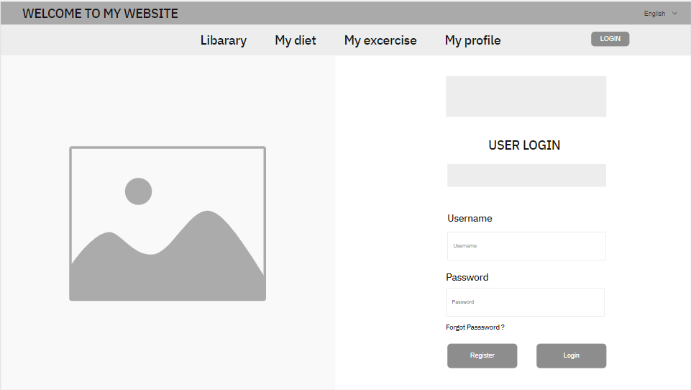

Figure 3.2.2. “Login” Mockup

|  |  |
| --- | --- |
| **Description** | The screen will appear if the user has not logged in for the first time or has logged out. |
| **Functional requirement** | * Password must be at least 8 characters. * The logo is small in size, appearing at the top of the form. * Forgot password and Register navigation buttons must be underlined. |

#### 3.2.2. Register

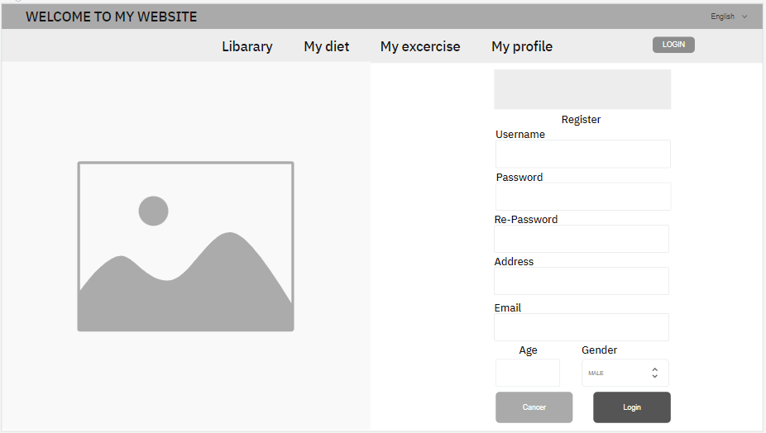

Figure 3.2.3. “Register” Mockup

|  |  |
| --- | --- |
| **Description** | This screen allows users to register with a new phone number to gain access to the system. |
| **Functional requirement** | * Phone numbers are limited to Vietnam region. * Password, re-enter password must be 8 characters long. * Provinces, districts and wards are limited to the Vietnam region. |

#### 3.2.4. Forgot password

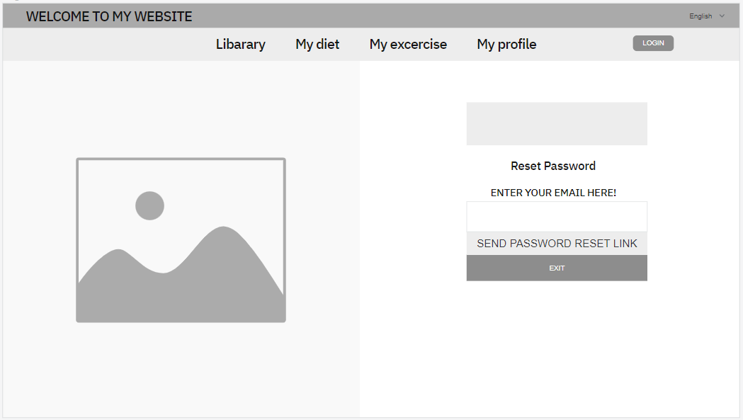

Figure 3.2.4. “Forgot password” Mockup

|  |  |
| --- | --- |
| **Description** | This screen allows users to reset their password when they forget the original password. |
| **Functional requirement** | * Password, re-enter password must be 8 characters long. |

#### 3.2.5. Email Validation

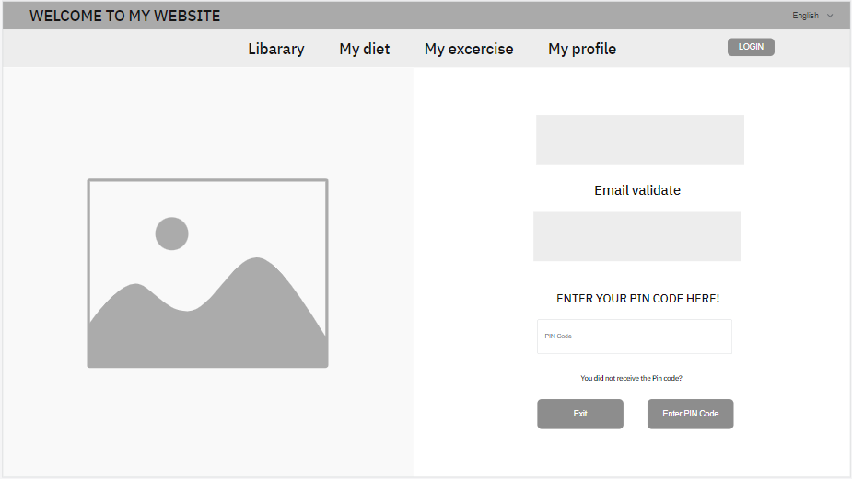

Figure 3.2.5. “Email Validation” Mockup

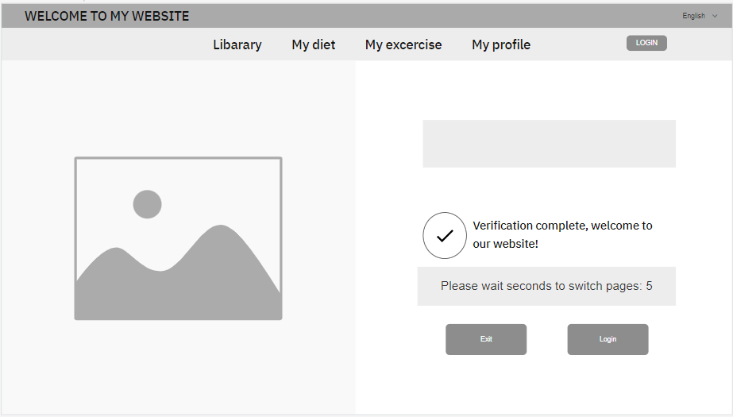

Figure 3.2.6. “Email successful Validation” Mockup

|  |  |
| --- | --- |
| **Description** | This screen is displayed in cases such as registration, forgetting password, changing phone number to be authenticated via email validation message. |
| **Functional requirement** | * Displays the email sending the email validation code. * The timeout for the resend button to show up is 1 minute. * The continue button will enable when the user enters all 6 numeric characters. |

### 3.3. Feature “Manage personal profile”

#### 3.3.1. Personal options

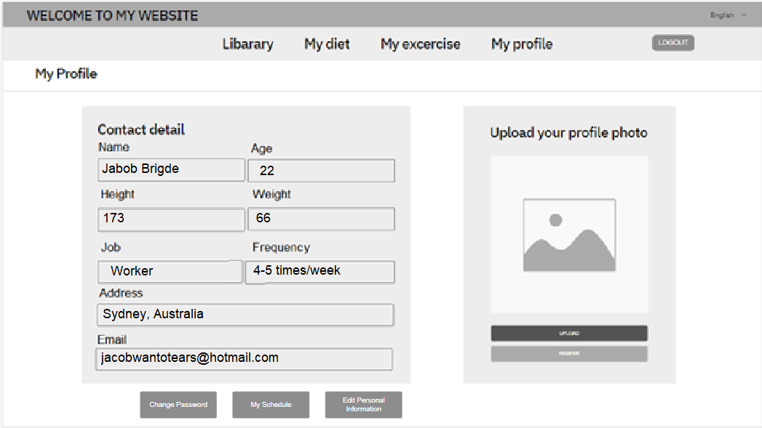

Figure 3.3.1. “Personal options” Mockup

|  |  |
| --- | --- |
| **Description** | This screen is displayed when the user clicks to view personal information on the navigation bar. |
| **Functional requirement** | * Show avatar, full name, number of catches. * The logout button should be colored red. |

#### 3.2.2. Edit personal profile

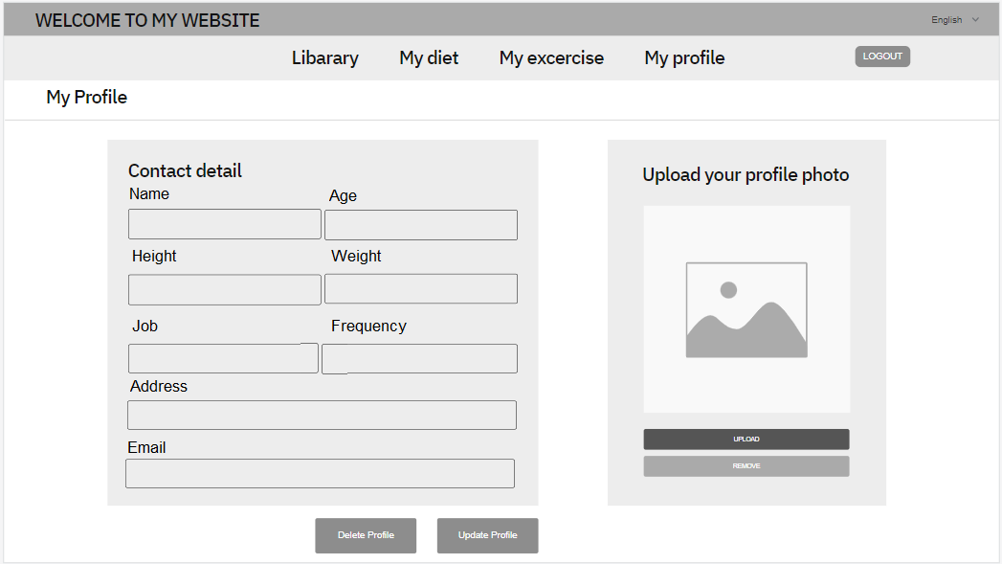

Figure 3.2.2. “Edit personal profile” Mockup

|  |  |
| --- | --- |
| **Description** | The screen displays full personal information of the user, and can be edited and updated. |
| **Functional requirement** |  |

#### 3.2.3. Change password

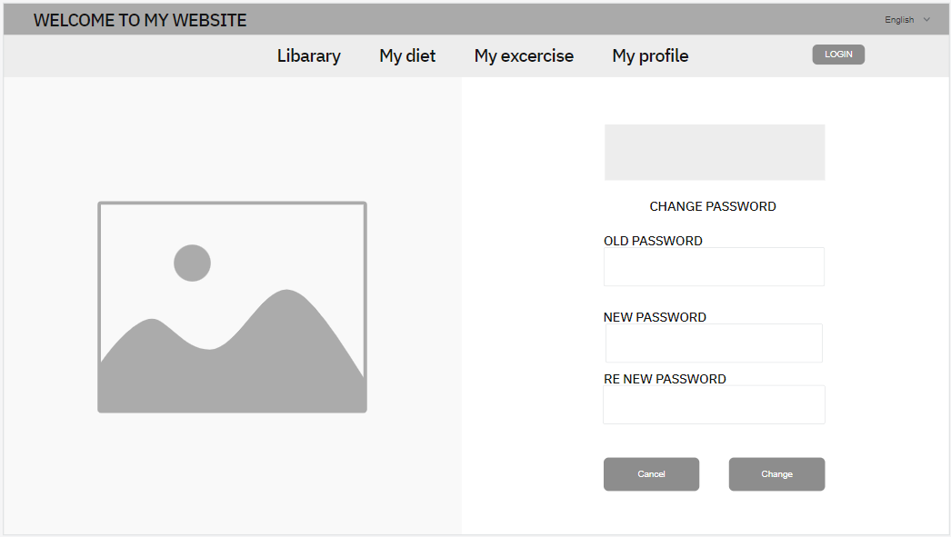

Figure 3.2.4. “Change password” Mockup

|  |  |
| --- | --- |
| **Description** | This screen allows the user to change to a new password. |
| **Functional requirement** | * Old password, new password, and re-enter new password must be 8 characters long. |

#### 3.2.4. Personal Schedule

Figure 3.4.1. “System account management” Mockup

|  |  |
| --- | --- |
| **Description** | This screen allows the user to see their dietary schedule. |
| **Functional requirement** | * Each day has 3 meals. It also display food information of each meals, calories values of each day. * User can click “Detail” to go to “Diet Detail” screen. |

### 3.4. Feature “Manage system accounts”

#### 3.4.1. System account management

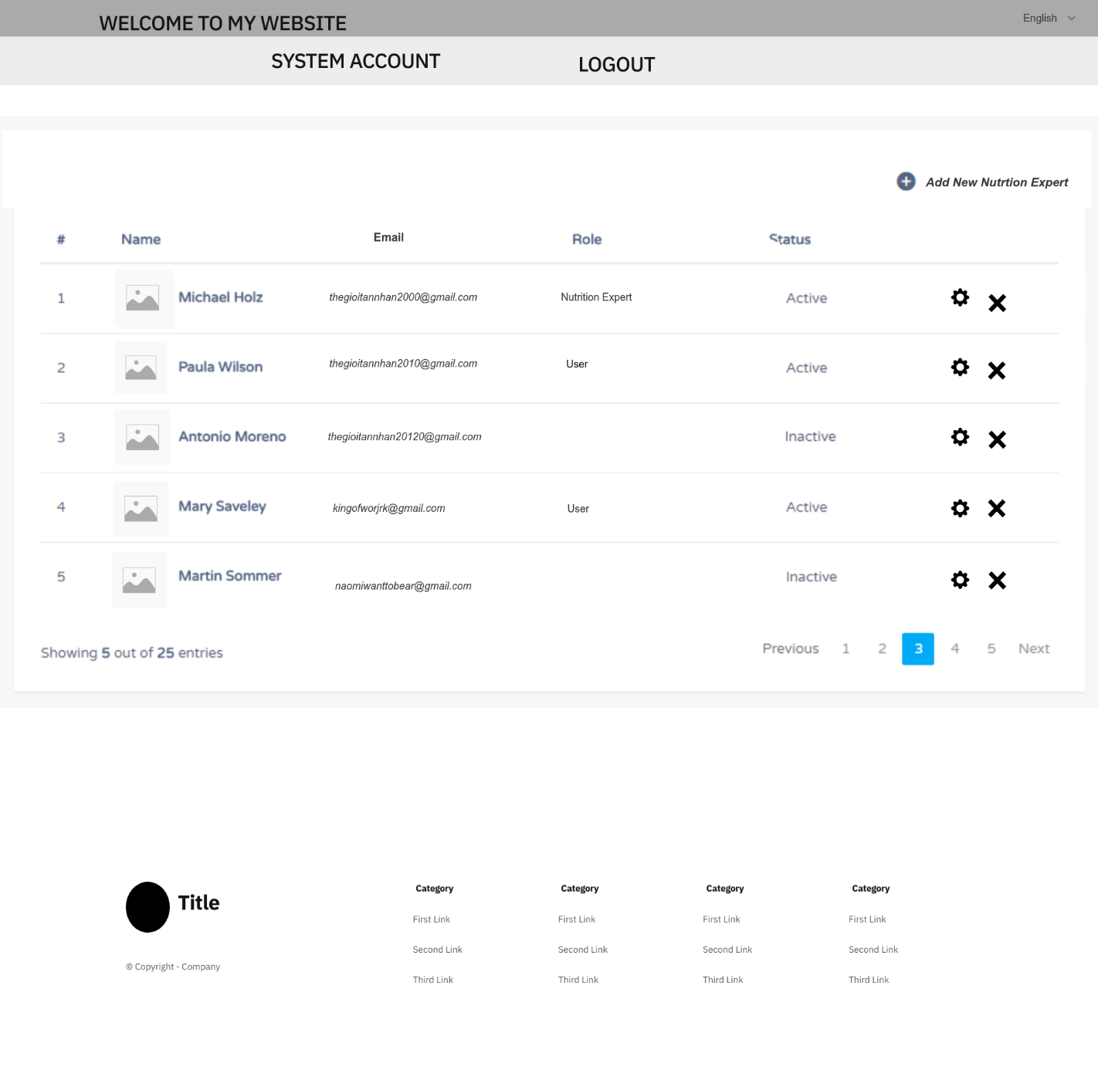

Figure 3.4.1. “System account management” Mockup

|  |  |
| --- | --- |
| **Description** | This screen allows the user to change to a new password. |
| **Functional requirement** | * Each card has an avatar, full name, email and status. * Administrators can search by name or by email. * If admin click onto “delete” icon, the system will display an alert message box to confirm the action. If admin click “Yes”, the account will be deleted. |

#### 3.4.2. Account details

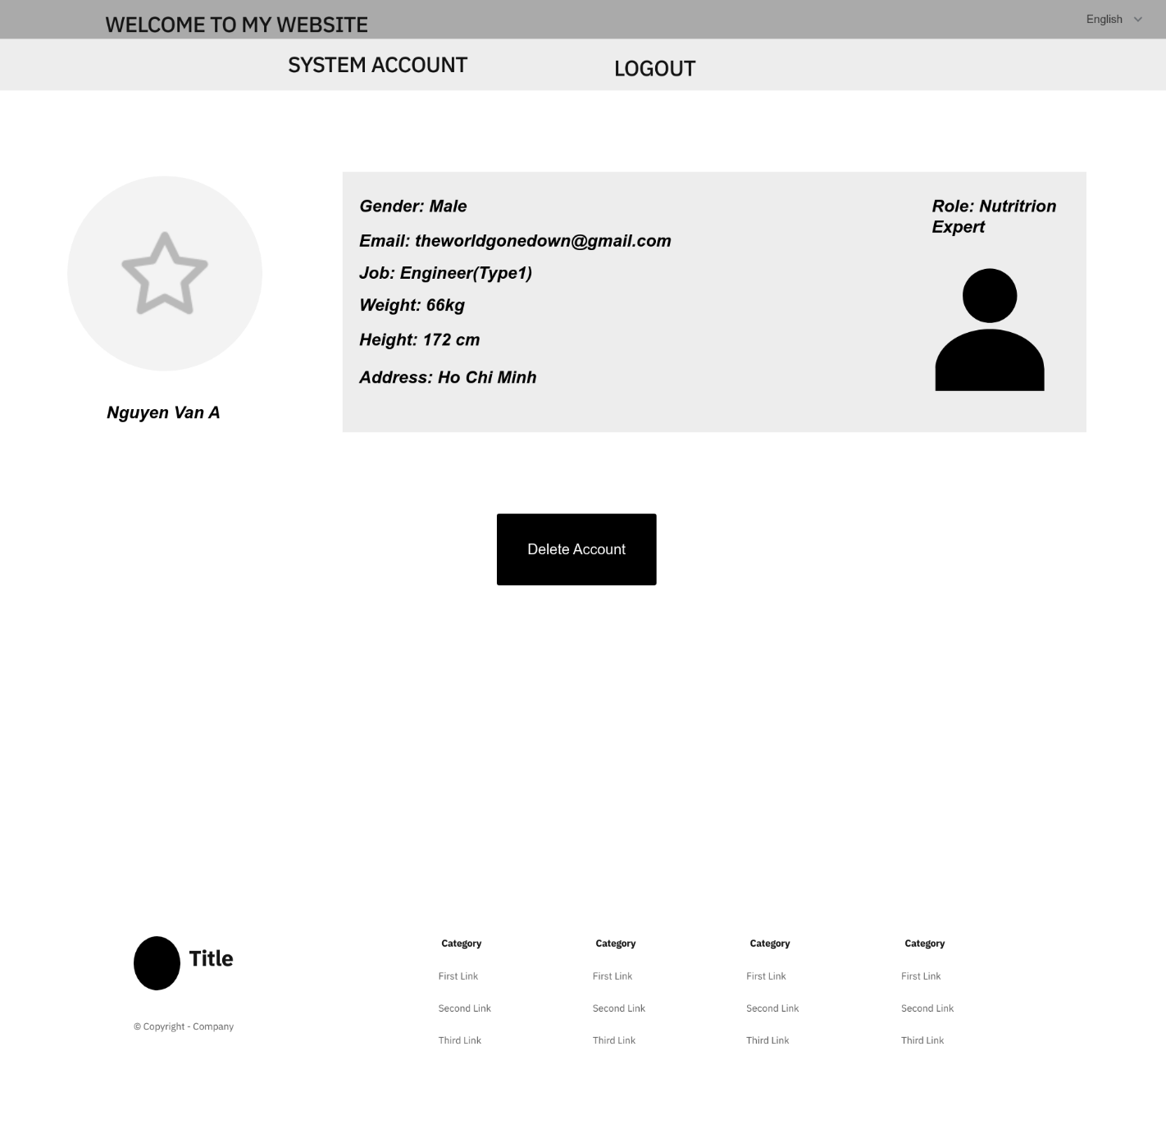

Figure 3.4.2. “Account details” Mockup

|  |  |
| --- | --- |
| **Description** | The screen displays full user information that only admins can access. |
| **Functional requirement** | * Show full avatar, full name, phone number, gender, date of birth, address and status. * The admin can’t edit user information. * The admin can click onto “Delete Account” to delete user’s account. |

### 3.5. Feature “Search foods”

#### 3.5.1. Search Food

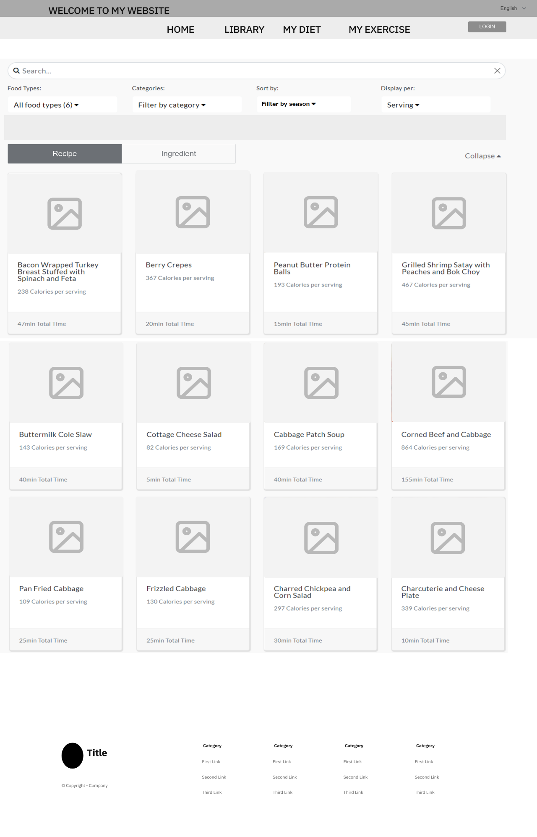

Figure 3.5.1. “Search Foods” Mockup

|  |  |
| --- | --- |
| **Description** | The screen shows the list of the foods that exist in database. |
| **Functional requirement** | * Show full avatar, full name, calories of foods. * Can filter by season and categories. |

#### 3.5.2. Search Ingredient

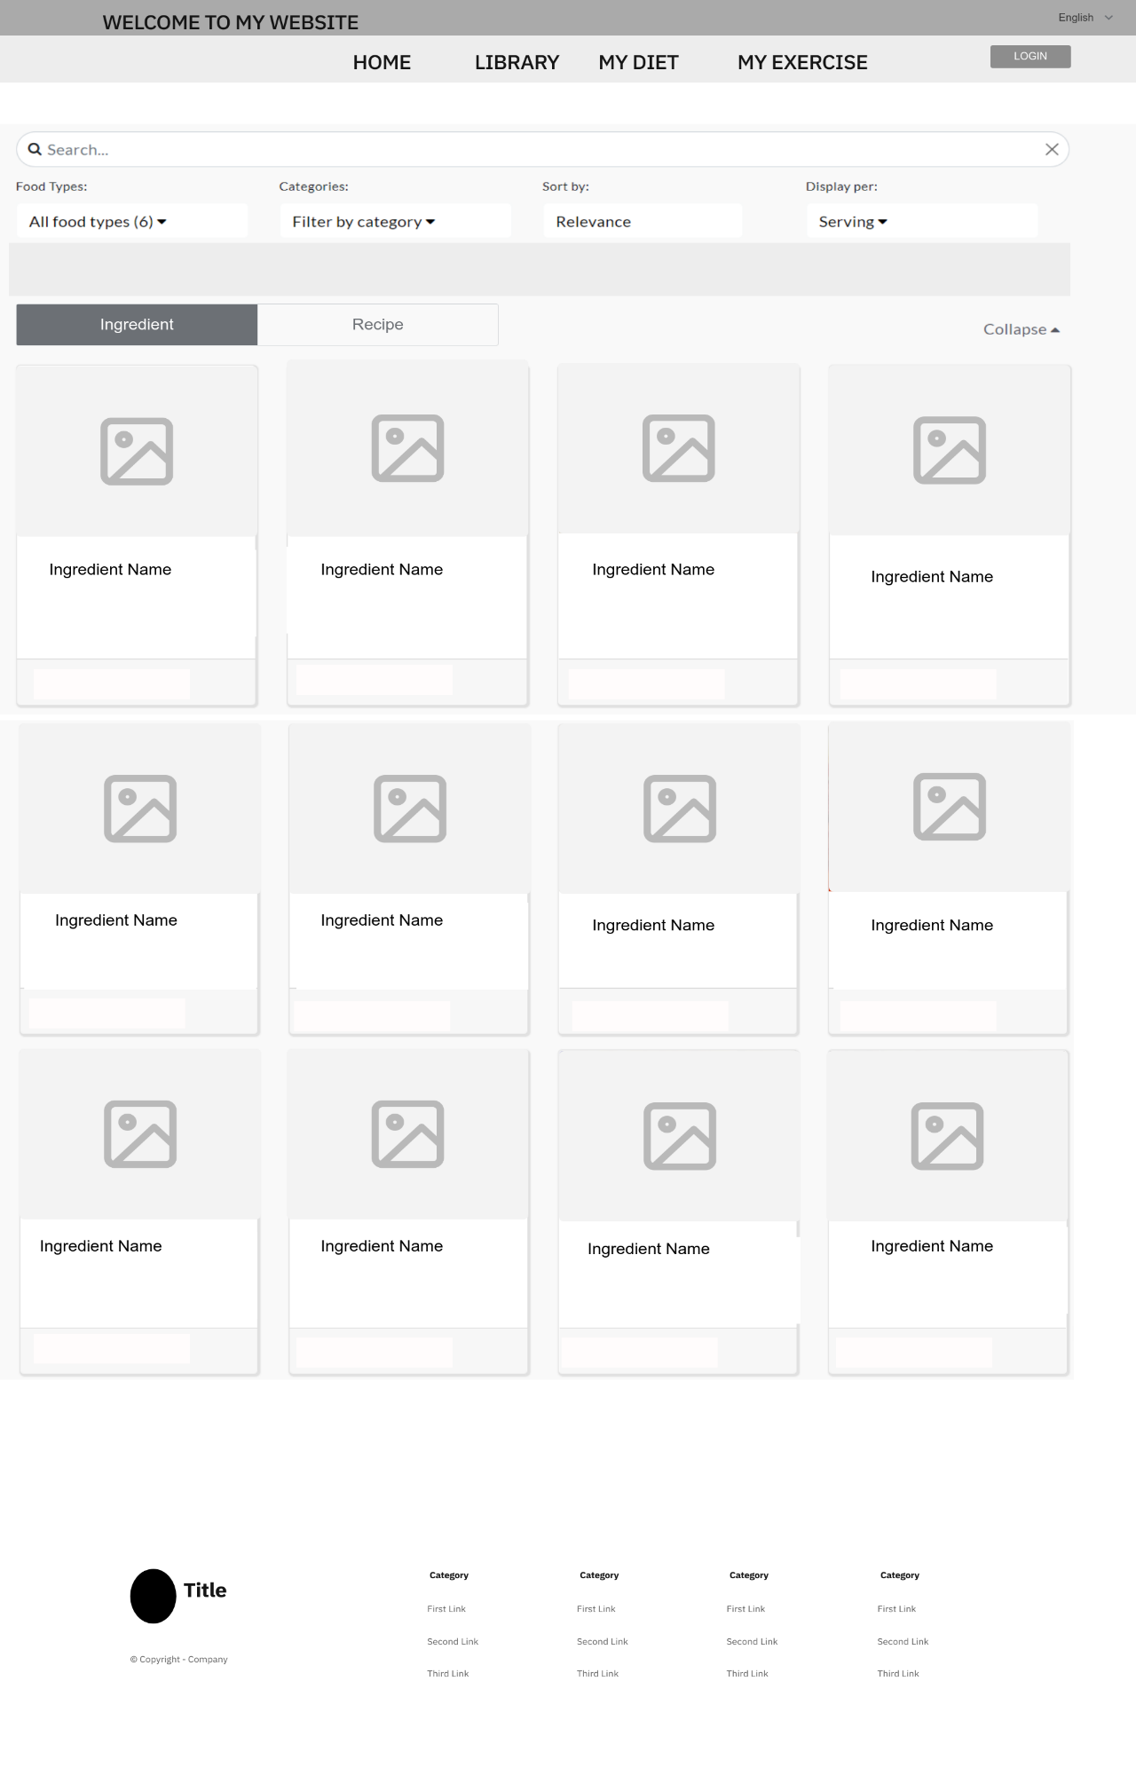

Figure 3.5.2. “Search Ingredient” Mockup

|  |  |
| --- | --- |
| **Description** | The screen shows the list of the ingredients that exist in database. |
| **Functional requirement** | * Show full avatar, full name, calories of ingredients. * Can filter by season and categories |

### Feature “Manage food”

#### 3.6.1. Add and Delete foods

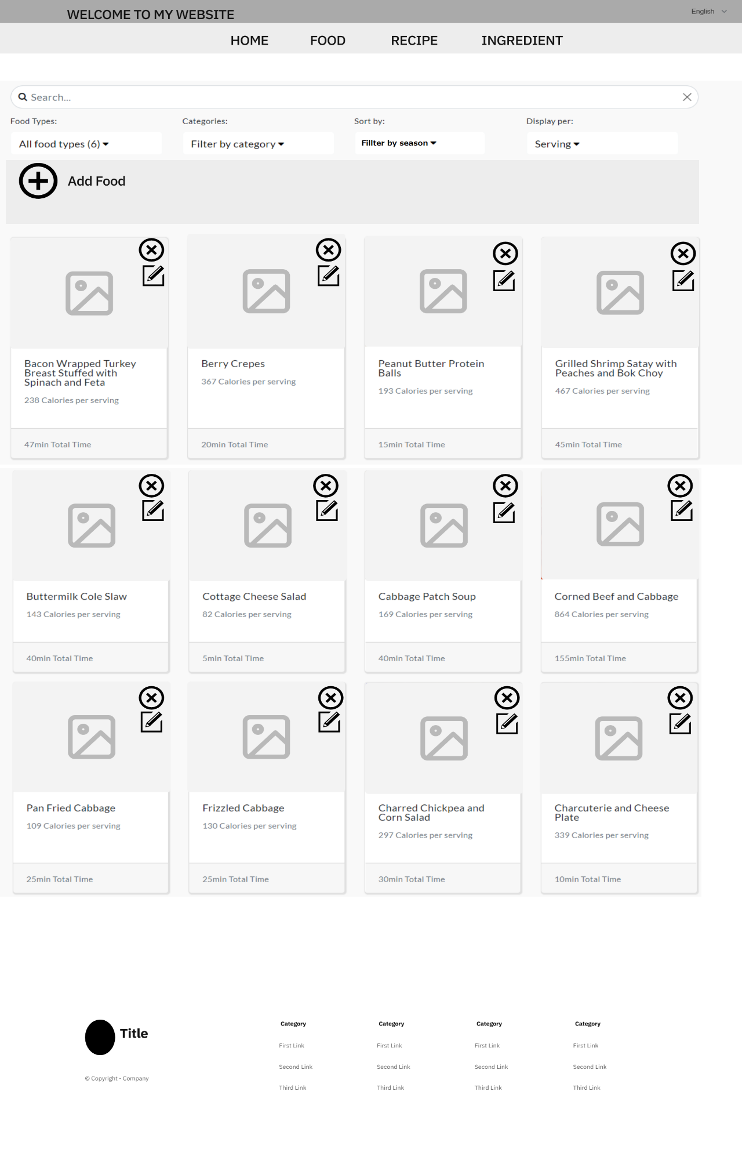

Figure 3.6.1. “Food List” Mockup

|  |  |
| --- | --- |
| **Description** | The screen shows the list of the foods that exist in database for nutrition expert to add and delete. |
| **Functional requirement** | * Show full avatar, full name, calories of foods. * Can filter by season and categories. * Nutrition Expert can add or delete foods. |

#### 3.6.2. Edit Food

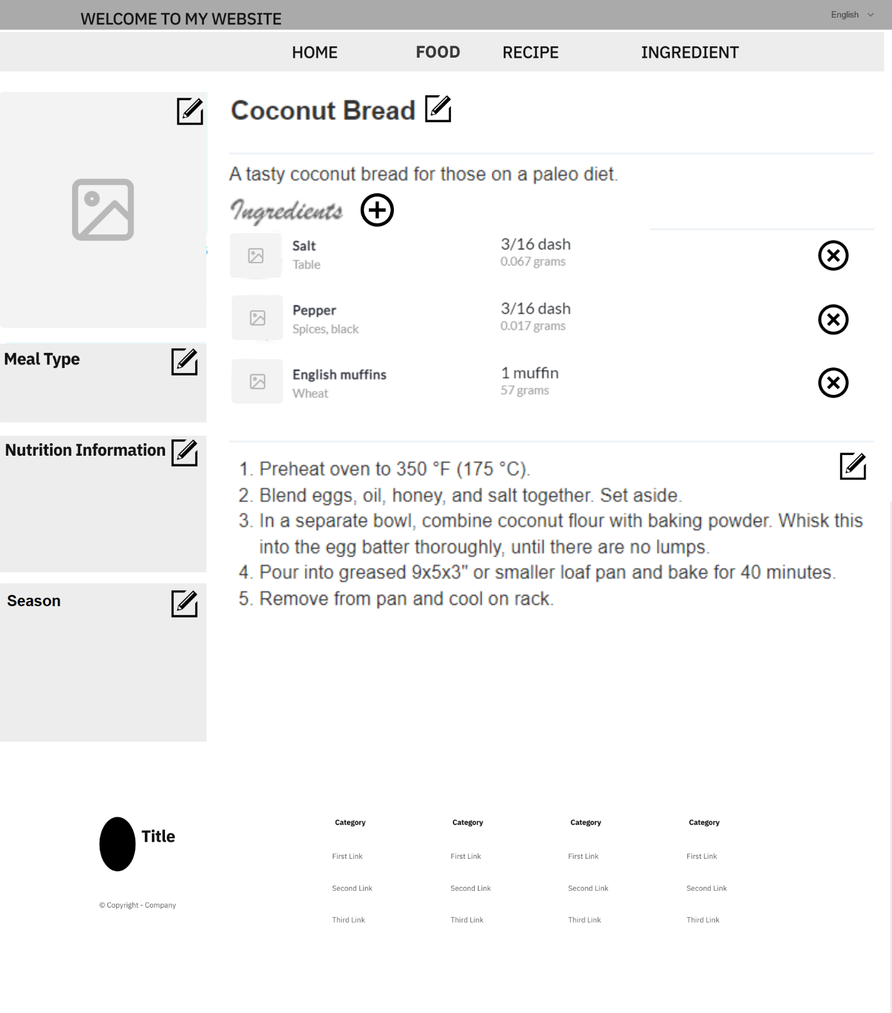

Figure 3.5.4. “Edit Food Detail” Mockup

|  |  |
| --- | --- |
| **Description** | The screen shows selected food detail for nutrition expert to edit. |
| **Functional requirement** | * Show full information of selected food. * Nutrition expert can delete or add ingredients into foods. |

#### 3.6.3. Add and delete ingredient

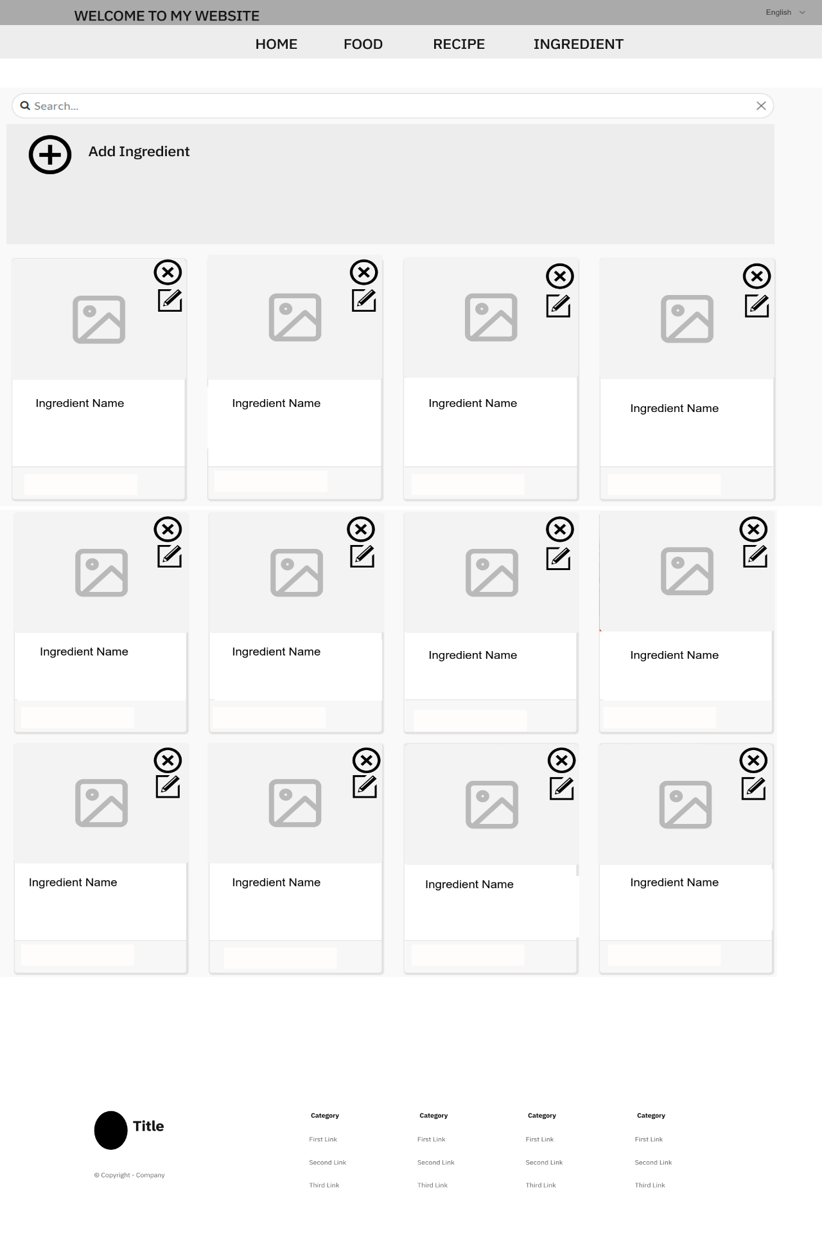

Figure 3.5.5. “Ingredient List” Mockup

|  |  |
| --- | --- |
| **Description** | The screen displays the full information of the ingredients in database. |
| **Functional requirement** | * Show full avatar, full name, calories of ingredients. * Can filter by season and categories. * Nutrition Expert can add or delete ingredients. |

#### 3.6.2. Edit Ingredient

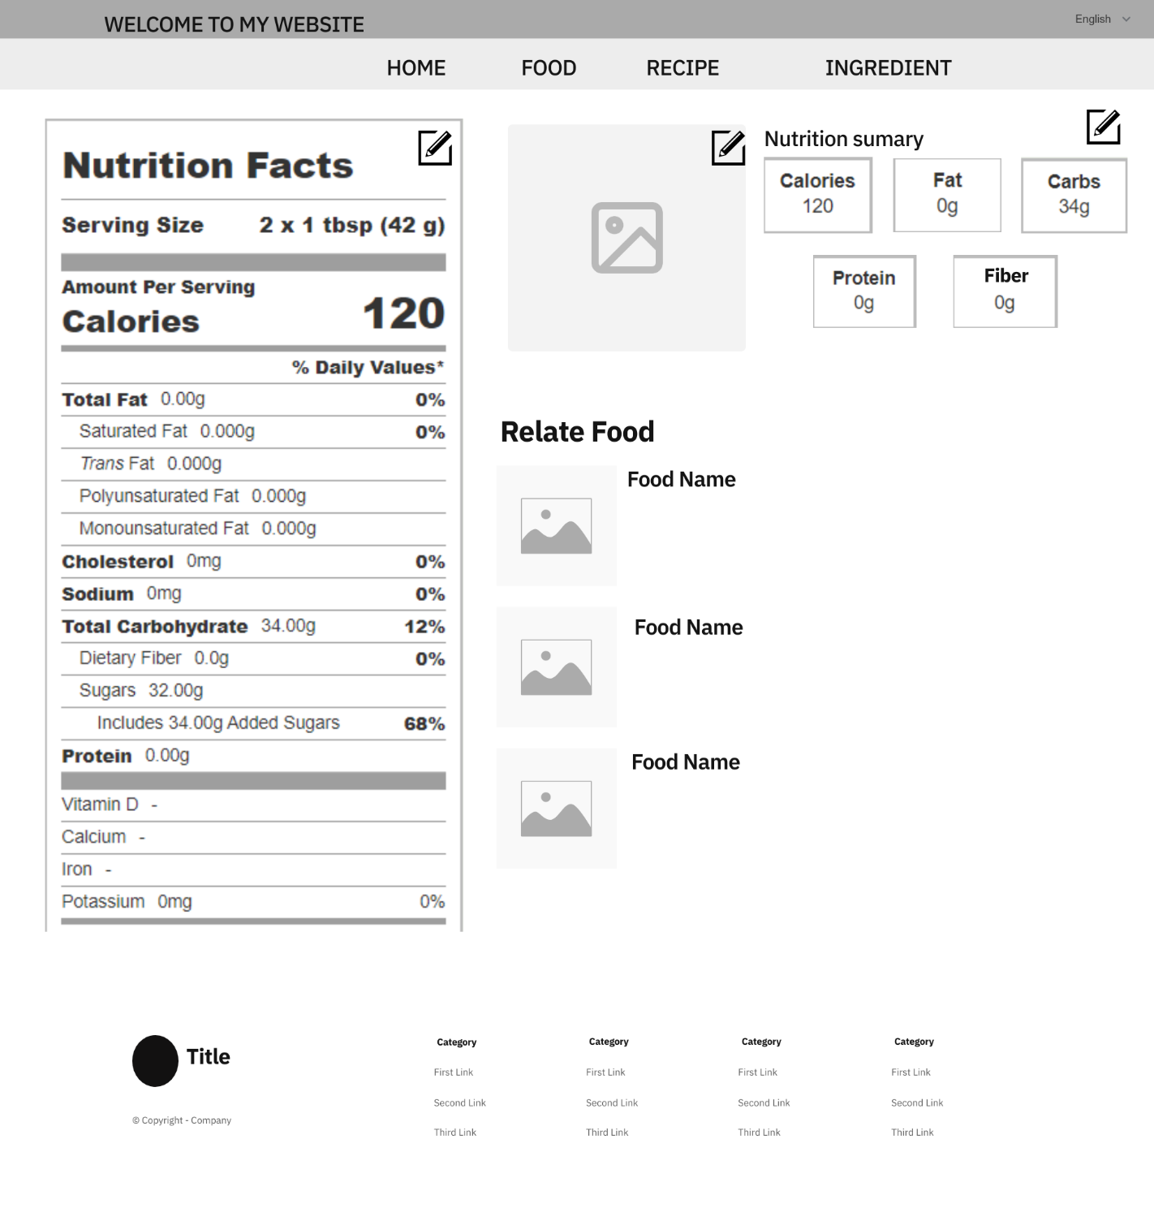

Figure 3.5.4. “Edit Ingredient Detail” Mockup

|  |  |
| --- | --- |
| **Description** | The screen shows selected ingredient detail for nutrition expert to edit. |
| **Functional requirement** | * Show full information of selected ingredient. |

### 3.7. Feature “Receive diet”

#### 3.7.1. View personal diet

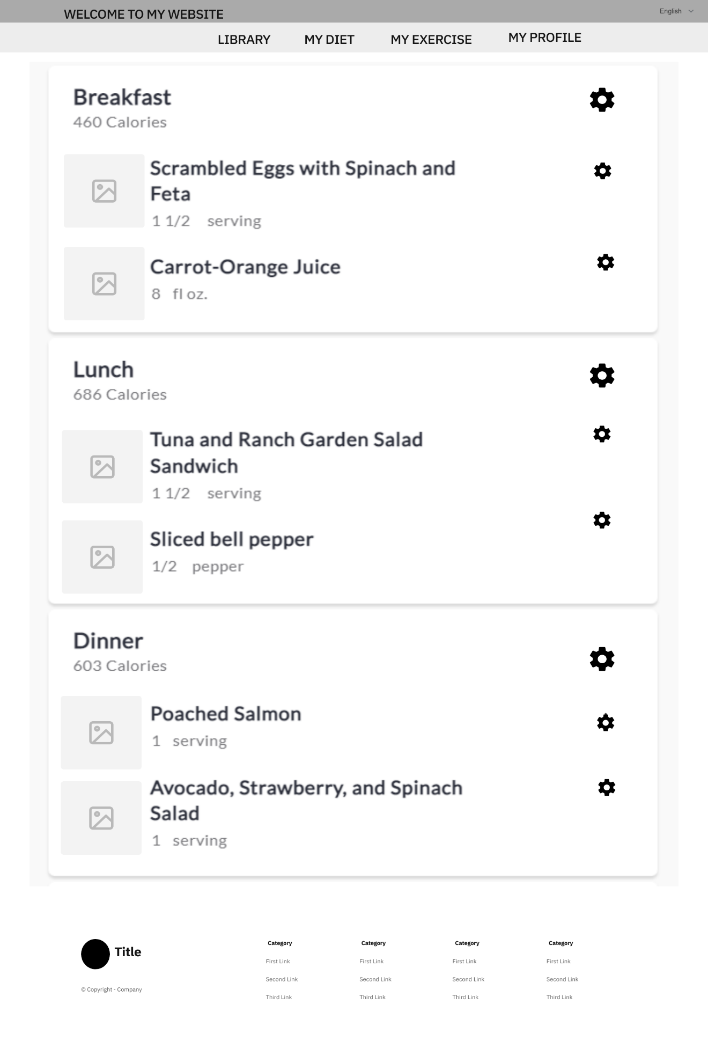

Figure 3.7.1. “View personal diet” Mockup

|  |  |
| --- | --- |
| **Description** | The screen shows the received diet of user in a day. |
| **Functional requirement** | * Daily diet has 3 meals: breakfast, lunch, dinner. * User can change foods in personal diet. |

#### 3.7.2. Input lacked information

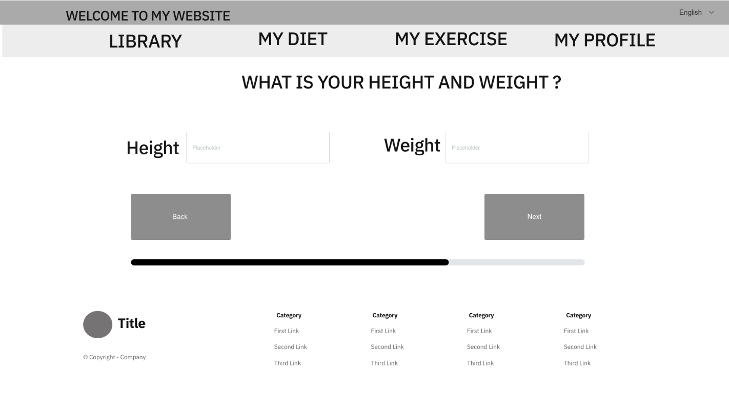

Figure 3.7.2.1 “Input weight, height” Mockup

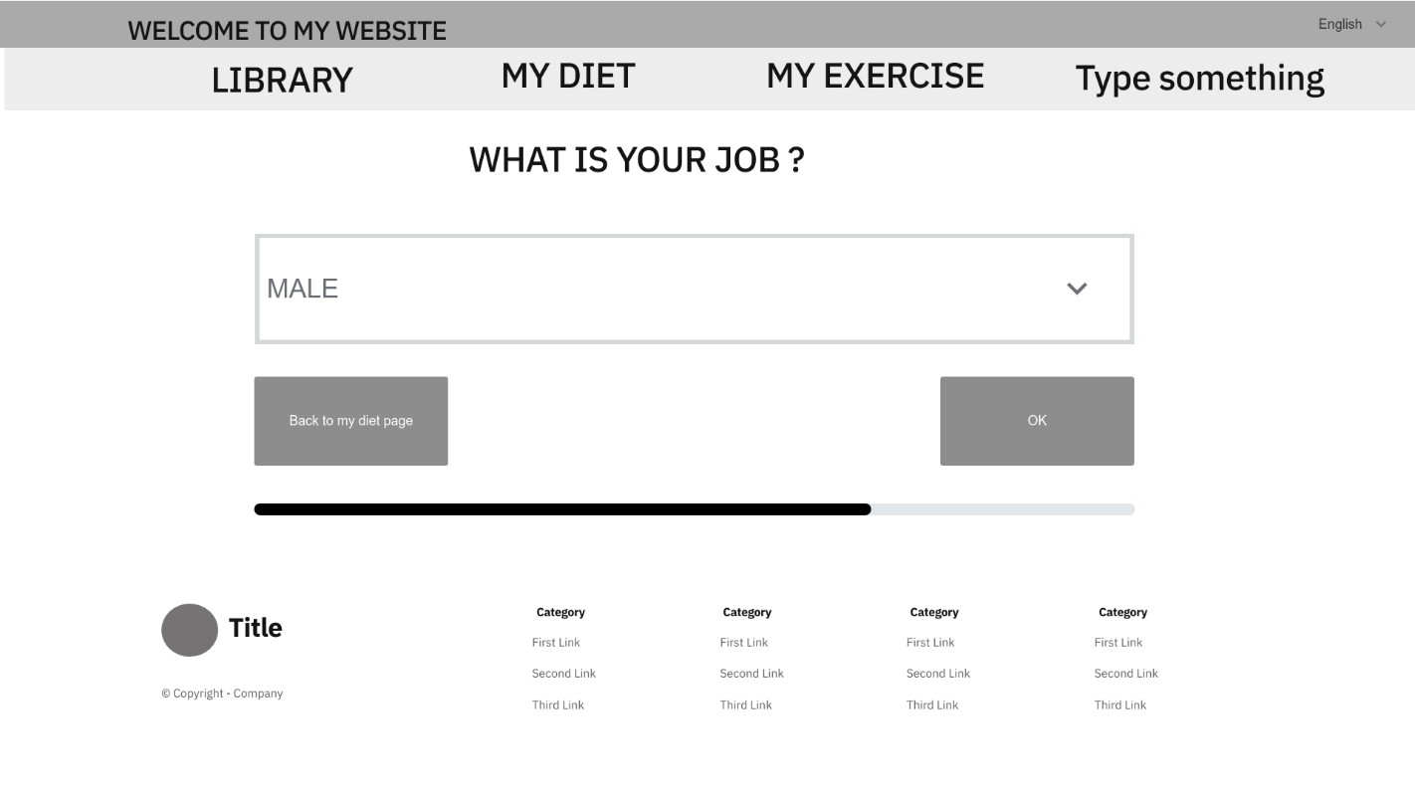

Figure 3.7.2.2 “Input job” Mockup

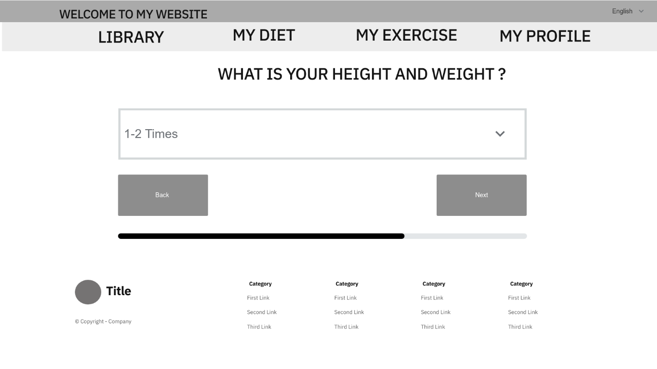

Figure 3.7.2.3 “Input frequency exercise” Mockup

|  |  |
| --- | --- |
| **Description** | The screen allows the user to fill lacked information before receive diet. |
| **Functional requirement** | * User have to fill all lacked information to continue. |

#### 3.7.3. Summary personal information

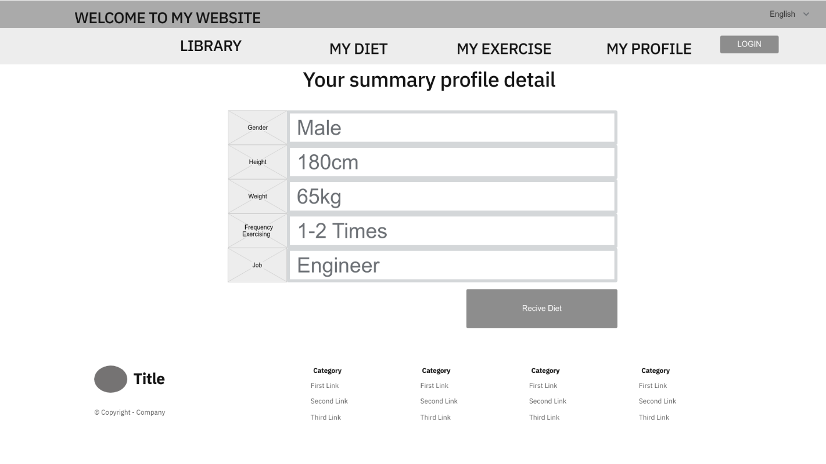

*Figure 3.7.3.“Input frequency exercise” Mockup*

|  |  |
| --- | --- |
| **Description** | The screen allows the user to fill lacked information before receive diet. |
| **Functional requirement** | * User have to fill all lacked information to continue. |

#### 3.7.4. Diet Detail

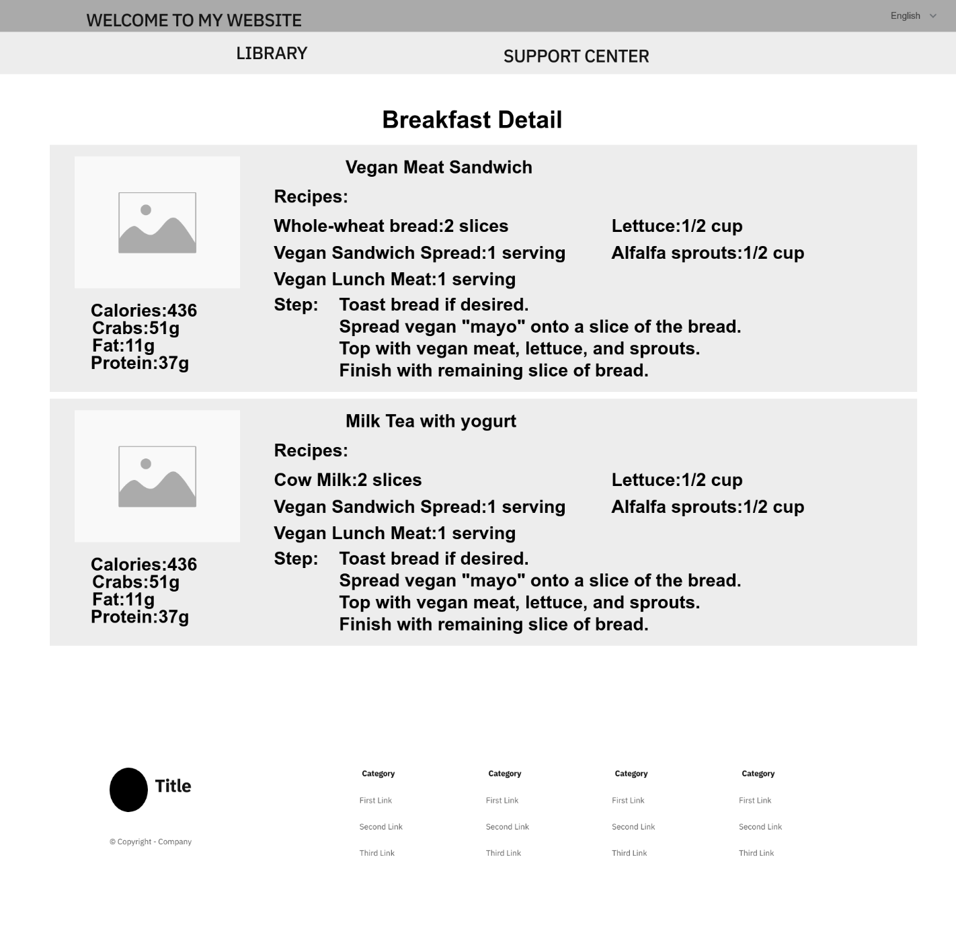

*Figure 3.7.4.1 “Breakfast Detail” Mockup*

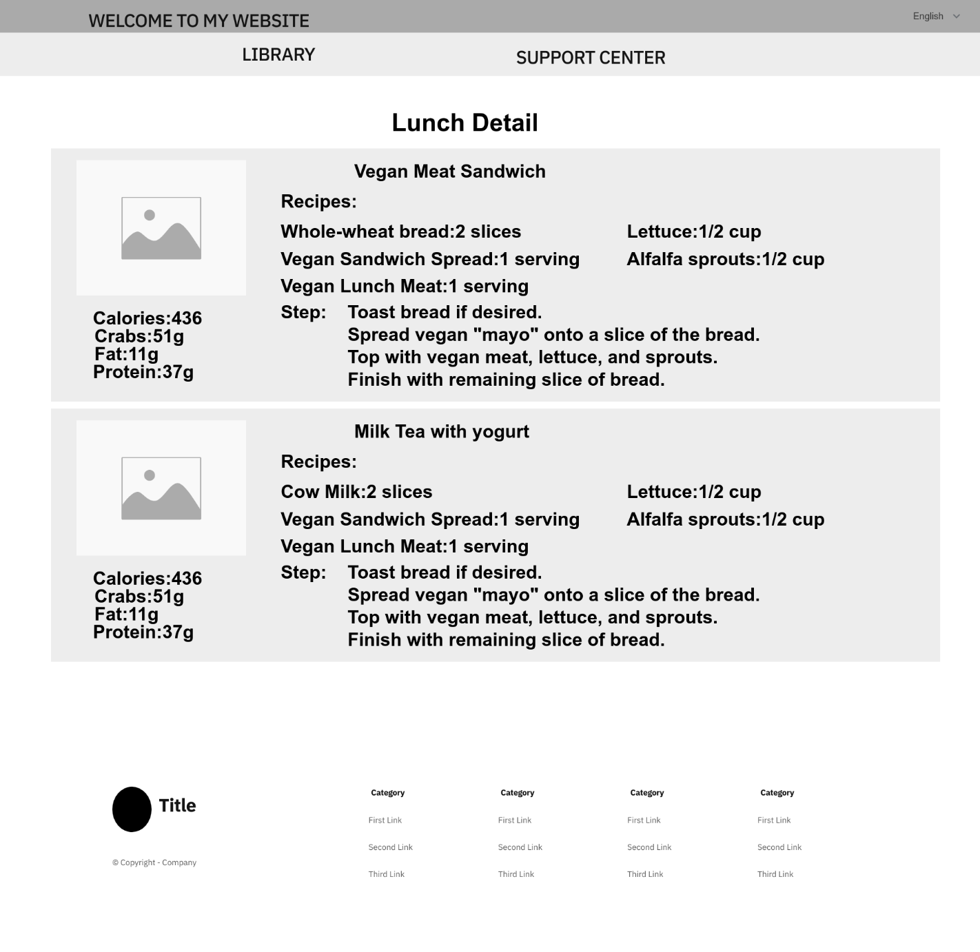

*Figure 3.7.4.2 “Lunch Detail” Mockup*

## 

## 

*Figure 3.7.4.3 “Dinner detail” Mockup*

|  |  |
| --- | --- |
| **Description** | The screen allows the user to see diet detail. |
| **Functional requirement** | * Diet detail must include 3 meals in a day. |

## 4. Non-Functional Requirement

### 4.1. Usability

* Links, buttons, and checkboxes are easily clickable.
* User interface should be clear and easy to use.
* The system must be designed so that users can easily familiarize themselves with and use competently functions in a short time. Main functions are organized into tabs for easier access.
* The maximum steps to complete 1 activity from seeing the screen is 3.

### 4.2. Security

* Using authentication and authorization to access protected resources.
* Password must be protected and encrypt before store in database.
* Only send the latest email validation to the user's email.

### 4.3. Performance

* In the best condition, the slowest response is not exceed 10 seconds.
* The loading pages time must not exceed 5 seconds.

### 4.4. Maintaining & Scalability

* System logs error reporting to track errors whenever the application happens to crash.
* Source code must follow the coding convention to help developers to read, understand, and find it easy to maintain or modify the code.

### 4.5. Compatibility

* The device must be Window 7 or higher.

## 5. Requirement Appendix

### 5.1. Business Rules

|  |  |
| --- | --- |
| **ID** | **Rule definition** |
| BR-01 | The user must provide phone number and password to login. |
| BR-02 | The date will be display in the format: dd/mm/yyyy. |
| BR-03 | The time will be display in 24-hour time. |
| BR-04 | The password must have at least 8 characters and alphanumeric. |
| BR-25 | Registering an account requires an email, password. |

Table 5.1. Business rules

### 5.2. Application Message List

|  |  |  |  |  |
| --- | --- | --- | --- | --- |
| **#** | **ID** | **Message Type** | **Context** | **Content** |
|  | MSG01 | In red, under text field | Login with wrong email or password | Email hoặc mật khẩu không hợp lệ |
|  | MSG02 | In red, under text field | Input required fields are empty | ${Tên_trường} không được bỏ trống |
|  | MSG03 | In red, under text field | Invalid Email Validation Code | Mã xác nhận email không hợp lệ |
|  | MSG04 | In red, under text field | Wrong email format | Email không hợp lệ |
|  | MSG05 | Toast message | Phone number is existed in the system | Ẻmail này đã tồn tại trong hệ thống |
|  | MSG06 | Toast message | Unmatched password | Mật khẩu không khớp |
|  | MSG07 | In red, under text field | New password must differ than old password | Mật khẩu mới không được trùng với mật khẩu cũ |
|  | MSG08 | Toast message | Confirm that verify information success | Xác nhận thông tin thành công |
|  | MSG09 | In grey, center of the screen | When the user or nutrition expert does not enter the search information, or there are no results returned | Không tìm thấy kết quả |
|  | MSG10 | In red, under text field | The user inputs wrong password format | Mật khẩu phải chứa ít nhất 8 ký tự |
|  | MSG11 | Toast message | Register successfully | Đăng ký thành công |
|  | MSG12 | Toast message | Change password successfully | Đổi mật khẩu thành công |
|  | MSG13 | In Grey, center of the screen | When search return empty | Kết quả tìm kiếm đang trống |
|  | MSG14 | In Red, under text field | There already a name like this exists in the system | Đã tồn tại ${STRING} với tên này |
|  | MSG15 | Alert message box, center of the screen. | Do you want to submit this information to get your diet? | Bạn có muốn gửi những thông tin này để nhận được chế độ ăn của mình chứ? |
|  | MSG16 | Toast message | Add new food successfully | Thêm thức ăn thành công |
|  | MSG17 | Toast message | Add new food fail | Thêm thức ăn thất bại. |
|  | MSG18 | Toast message | Add new ingredient successfully | Thêm nguyên liệu thành công |
|  | MSG19 | Toast message | Add new ingredient fail | Thêm nguyên liệu thất bại |

Table 5.2. Application Message List